Caroline Patatt

impact of COVID-19 on journalism: a case study of the Brazilian channel SporTV
La Convergencia como herramienta frente a los impactos de la COVID-19 en el
ARTICLE
periodismo: un estudio de caso del canal brasileño SporTV
6
Convergence as a tool against the
Universidade da Beira Interior (Portugal)
Caroline Patatt is a Brazilian journalist, a researcher at the Foundation for Science and Technology (FCT) in Portugal and a PhD candidate in Communication Sciences at the University of Beira Interior (UBI). She is currently studying sports journalism, with a particular interest in the objectification of women in the field.
cpatatt@gmail.com
ORCID: https://orcid.org/0000-0003-2836-7915

RECEIVED: 2023-05-31 / ACCEPTED: 2023-07-19

Abstract
This study presents how convergence in tech- nological, professional, content and business dimensions (Salaverría, 2003, 2010) was crucial in overcoming the difficulties imposed by CO- VID-19 on the productive routines of Brazilian sports journalism, based on an analysis of the SporTV channel. As a leader in audience ratings among sports channels, SporTV was the first in the country to adapt a program fully for remote broadcasting from participants’ homes during the pandemic. The case study, based on con- tent analysis and interviews, was the research techniques used.
KEYWORDS
Convergence, COVID-19, Sports Journalism, SporTV, Brazilian Television.
Resumen
Este trabajo presenta cómo la convergencia en las dimensiones tecnológica, profesional, de contenidos y empresarial (Salaverría, 2003, 2010), fue fundamental para superar las dificul- tades impuestas por la COVID-19 en las rutinas productivas del periodismo deportivo brasi- leño. Se basa en un análisis del canal SporTV, que es líder de audiencia entre los especiali- zados en deportes y fue el primero en el país en mostrar un programa adaptado comple-

OBRA DIGITAL 24, December 2023, pp. 105-123, e-ISSN 2014-5039
DOI: https://doi.org/10.25029/od.2023.386.24
105

tamente para ser transmitido desde las casas de los participantes durante la pandemia. La técnica de investigación utilizada fue el estudio de caso, basado en el análisis de contenido y la entrevista.

INTRODUCTION
Over the years, sports journalism has estab- lished itself as a pioneer in terms of digital innovations, as it has experienced updated narratives in this sense, as well as new tools, changes in the configuration of workplaces, in the type of production, and the use of content (Boyle, 2017; Ferrucci & Perreault, 2022; Mor- rison, 2014; Patatt, 2023; Perreault & Nölleke, 2022). Much of what is observed in newsrooms in this specialty in different parts of the world today presents characteristics of what Salaver- ría (2003, 2010) defines as convergence, espe- cially in the technological, professional, content, and business dimensions.
Taking this reality into account, this paper aims to verify which aspects of the dimensions men- tioned above of convergence were present in Brazilian television sports journalism during the COVID-19 pandemic and how these elements collaborated to overcome the crisis in the sec- tor. The interruption of major sports competi- tions around the world has had a significant im- pact on the development of activities, especially in television, and has required the adaptation of working methods and productive routines (Bradshaw, 2020; Patatt, 2021; Perreault &
Nölleke, 2022).
Specifically, it sought to test hypotheses relat- ed to the importance of developing journalists’ technological knowledge, especially concerning the operation of audio and video devices. We also investigated the effects of reducing the number of professionals working in the news- rooms, either in person or organized in a net-
PALABRAS CLAVE
Convergencia, COVID-19, Periodismo Deporti- vo, SporTV, Televisión Brasileña.

work through the Internet, and how integrated work would have supplied different commu- nication channels within the same journalistic group.
To achieve the objectives, the case study was used as a research technique (Gil, 2008; Yin, 2005), which is focused on content analysis - applied to thirty editions of the Redação SporTV program - and interviews.
It is important to note that sports journalism on Brazilian television has been developing since the 1950s, in the early days of national televi- sion, and was gaining relevance at the same time as the popularity of football increased. This reality led the country’s broadcasters to invest considerably in this segment.
The Brazilian channels have been pioneers in many aspects worldwide. Even before the decade of 1980, they already used exclusive software, private satellites, and equipment ca- pable of taping underwater, for example, and slow-motion cameras while transmitting signif- icant events. In 1982, the Brazilian broadcaster Rede Globo was the only broadcaster in the world to have at least one reporter in each of the 14 football World Cup host cities (Memo- ria Globo, 2021). Currently, the SporTV channel alone, the subject of this study, took nearly 200 journalists to cover the 2018 World Cup in Rus- sia.
SporTV is one of three channels with daily news production and a focus on various sports, along with ESPN and BandSports, all availa- ble by subscription only. Sports debates fea- ture prominently on all three channels. Even

the newscasts and e-magazines have at least one commentator in the studio to engage in dialogue and discussion with the other partic- ipants in the program. These are inherent char- acteristics of the format (Fechine, 2001).
The analysis in this paper focuses on SporTV because it is the national audience leader in its segment, both currently and in the run-up to the SARS-CoV-2 pandemic (Vaquer, 2020), and because it was a pioneer in the country for hav- ing a program wholly adapted to be broadcast from participants’ homes during the pandem- ic. We are referring to the program Redação SporTV, which has been on the calendar for almost two decades; it temporarily changed its name to Redação Home Office.
These characteristics mean that Brazil is con- sidered a fertile field for analyzing evolutionary issues related to this journalistic specialization, such as the case of convergence.

THE IMPACT OF COVID-19 ON JOURNALISM AND SPORTS JOURNALISM.
The COVID-19 pandemic has altered how jour- nalism is done worldwide, regardless of seg- ment, specialty, or function. The number of studies on the subject is multiplying as these modifications become more evident, as well as the perpetuation of some measures taken at the most critical moments of the disease’s spread, apparently emergent, but which have been maintained.
It is not the aim to discuss positive or negative aspects here but to contextualize a quite com- plex reality. Despite the immense difficulties in the production processes, there is hard work to combat misinformation and face many oth- er challenges from an operational perspective (Mair, 2020; Patatt, 2021, 2023; Patatt & Rocha,
2020; Perreault & Nölleke, 2022). Moreover, during the pandemic, there have also been increases in news consumption in major mar- kets, such as in the United States, where 92% of adults frequently access news on the topic, in a kind of re-approximation of the public to traditional media
[...] an increase of 32 percentage points compared to the period before the health emergency. The most sig- nificant increase in news consumption and positive evaluation of media cov- erage of the pandemic was observed among users previously unrelated to the news, such as young people, peo- ple with less education, and occasional consumers of information. (Casero-Ri- pollés, 2020, p.9)
Specifically, in sports journalism, the vulnera- bility to which this specific area was subjected also led to a review of activities. For example, the criteria for which sports were worthy of being televised were redefined: faced with the impossibility of broadcasting high-performance competitions due to canceled events around the world, lack of training, and other difficul- ties, ESPN in the United States even broadcast a stone-throwing tournament, and one of the most popular sports channels in the Nether- lands was successful with the so-called Mar- bula One, a kind of marbles race (Perreault & Nölleke, 2022).
In Brazil and Germany, broadcasts of historic matches of national teams increased (Patatt, 2021; Schallhorn & Kunert, 2020). In the case of Germany, the specialized channel Sky even tried to emulate full days of Bundesliga matches as if there had been no coronavirus, including the “traditional pre- and post-match reports and a fictitious scoreboard” (Schallhorn & Kunert, 2020, p. 517). Also, in Brazil, the sport-

ing agenda was more linked to social, political, economic, and cultural issues (Patatt, 2021; Longo, 2020).
While these alternatives may be questiona- ble, it is undeniable that creativity is essential to overcome professional difficulties (Mosby, 2020). The need to inform and the challenges in obtaining new images, especially on televi- sion, meant that audio and video quality took a back seat. Less conventionally, material from social media, football clubs, etc., was used. This broadened the relationship with sources (Patatt, 2023).
Götz and Costa (2021) point out that the action in multiplatform format gained more space in Brazilian radio stations. This is in line with Ols- en, Pickard, and Westlund (2020), who argue that the economic effects of this unique period in human history were decisive in accelerating changes in production, distribution, consump- tion, and business models of new in general, not only in sports.
In this line, García-Avilés (2021) describes the adaptation to remote work from communica- tion enterprises in Spain, especially concerning the structure of newsrooms.
Journalists quickly adopted remote work, new communication protocols were created, and practices were adapted [...] The consolidation of remote work has brought unprec- edented organizational changes to newsrooms, accelerating digital trans- formation. These changes can become permanent in most news organiza- tions: (pp. 1256-1257).
Especially in this one, but also in the other works mentioned, it is possible to note the de- tails and applications related to the ideas of convergence, which will be discussed in more detail below.

CONVERGENCE IN JOURNALISM
Salaverría, García Avilés and Masip (2010) es- tablish a concept of journalism convergence based on the idea that a generalized imple- mentation of digital technologies in commu- nication affects the practice of journalism on a day-to-day basis in different forms “[...] by fostering an integration of previously disparate tools, spaces, working methods, and languag- es so that journalists produce content that is distributed across multiple platforms, using the languages of each one”(p. 59).
Convergence can be addressed more specifi- cally in different dimensions, such as techno- logical, professional, content, and business (Salaverría, 2003, 2010) - all related to this re- search - but all interconnected.
The internal subdivisions and hierarchies in the profession, established since the 20th century, have changed, especially in the last two dec- ades. In 2012, the research entitled Profession- al Profile of the Brazilian Journalist pointed out 288 descriptions of new roles and 177 new ac- tivities related to journalistic practice, including digital media and strategy coordinator, digital content analyst, blog writer, and social mobili- zation analyst.

New characters, known as techno-actors, have emerged in newsrooms (Canavilhas et al., 2015). They are professionals with extensive techno- logical mastery who work in the same medium as journalists but are not journalists, although they have the power to produce news. Exam- ples of occupations that fit this idea of tech- no-actors include designers and programmers.
In short, reporters and editors who used to have control over the news- room now need to establish negotia- tion mechanisms with professionals trained in other areas and operate according to different logic to carry out their primary mission. Journalists, designers, and programmers think and act differently, but when they work together in the same newsroom, they have a common purpose: to produce information. (Canavilhas et al., 2016, p. 4)
These are examples of how technological con- vergence goes beyond journalists’ use and do- main of new tools and devices. It interferes with the ecosystems of editorials, how journalism is done, and how the news reaches the public. In other words, it has an impact from a profes- sional, content, and business perspective.
Talking about convergence in journalism, in many media companies, implies optimizing space, time, and human resources. There are more tasks to be carried out in the same pe- riod and most of the time with fewer people, but in different functions, as well as large teams sharing adapted spaces. Various media belong- ing to the same business group, which used to work in separate sectors, floors, or buildings, now often coexist in integrated newsrooms.
According to Salaverría (2010), the first significa- tive international example of newsroom fusion took place in 2000 by the American group Me- dia General in Tampa, Florida, where the Tampa Tribune journal, the Bay Online (TBO.com) local portal, and WFLA-TV televisión station gathered in one place.
Santos et al. (2014) synthesize some definitions from different authors for network conver- gence models:
The first is full integration, in which the infrastructure for multiplatform production is concentrated in a sin- gle newsroom, controlled by a central news and workflow management sys- tem [...] The second model is a collab- oration between newsrooms, in which journalists work in different sections and newsrooms but are connected through their multimedia coordina- tors or certain collaborative routines along the news flow [...]. Finally, there is the model of coordination of isolated media. In this case, there is no organ- ization of integration in the workflow. There is only a voluntary collaboration of each journalist in the news produc- tion process. (Santos et al., 2019, p. 107)
Deuze and Witschge (2017) point out that “The newsroom is not necessarily a solid or coher- ent entity in today’s post-industrial journalism” (p.166). It is possible, and in some cases con- sidered a trend, to work outside of it, at a dis- tance, and in total synchronicity with the more profound ideals of convergence.

Canavilhas (2012) states that “you can only speak about convergence when the final prod- uct is content with unique characteristics” (p. 9). The researcher refers to content convergence: it is not enough to distribute information ma- terial on different platforms. If so, it could be considered simply as a remediation:
By remediation, we mean the process of renewal of old content carried out by new media [...] There is an essential difference between the two concepts: while convergence necessarily implies a new language that integrates old content, remediation can be an accu- mulation of content from different ori- gins distributed on the same platform. In this sense, convergence is always remediation, but not all remediation can be considered convergence, as convergence implies integration and not a mere accumulation of content. (Canavilhas, 2012, pp. 9-10)
On the other hand, it is possible to consider the harnessing of interactivity through the internet (through digital social networks, email, etc.) as a genuine form of convergence, as it manages to use information originating in one medium and transform it in a way that encompasses char- acteristics of another (e.g., radio or television), generating something completely new.
It would not be impossible, but it seems more challenging to consolidate the idea of concen- trating efforts in favor of a singular objective and still have professionals working separate- ly in no longer existing sectors. On the other hand, while representing an important step, such physical issues do not guarantee effective convergence.

METHODOLOGY
To achieve the goal of investigating the con- tribution of convergence in overcoming the impacts of COVID-19 in Brazilian sports jour- nalism, the SportTV channel, belonging to the Globo Communication Group, has been estab- lished as the object of investigation. It has ex- isted since 1994 when it replaced Top Sports, the first specialized sports program offered by a Brazilian pay-TV broadcaster, Globosat, also part of the Globo Group. Top Sports was on the air from 1991 to 19941.
Before the pandemic caused by the SARS- CoV-2 virus, SporTV was the leader in the au- dience among all channels available by sub- scription in the country and, at some points, was also among the top five Brazilian television channels, including the generalist free-to-air channels, i.e., non-paid, with varied content and available for free access by the population. This popularity is maintained in 2023 (Carvalho, 2023).
In addition to this projection in national sports journalism, the fact that the station was the first in the country during that pandemic state to have a program fully adapted to be made and broadcast directly from the home of the pre-

1 Available: http://canaisglobosat.globo.com/. Access Jan- uary 14, 2021.

senter and the participants was a crucial factor in defining SporTV as an object of analysis.
The outstanding program is called Redação SporTV and has been broadcast since 2004. It is inspired by Meet the Press from American television, also to debate the coverage by the press. Thus, it gathers journalists and has the audience’s participation through digital social networks.
Traditionally, it is broadcast from Monday to Friday, from 10:00 to 12:30 Brasilia time. It fea- tures at least two commentators and reporters who mainly participate live. It is defined as a round table but combines elements of a televi- sion news program.
The COVID-19 pandemic meant that, from 30 March to 22 June 2020, Redação SporTV was presented directly from participants’ homes, leading to a temporary change of name: Redação Home Office.
Patatt (2021) conducted research focused on the overall impact of the COVID-19 pandem- ic on Brazilian sports journalism, in which he presents a general analysis of the modification above in Redação SporTV. It is essential to men- tion, for a better understanding of some impor- tant structural aspects of the program, that, in addition to the change in the program’s name, adjustments were made to the introduction and visual characteristics in line with the video- conference proposal. A software called Cloud- cast, operated via the Internet, was used for the realization of the program, which required a reduction in the number of participants. The time on the programming grid and the dura-
was presented only from 13:00 to 14:00, also from Monday to Friday, then the time was grad- ually increased as sporting activities resumed around the world. It became the only attraction broadcast live daily on SporTV.
To conduct a sequential study to that of Patatt (2021) but with different objectives, hypothe- ses, and research techniques, the same period of analysis as the authors are used: thirty edi- tions of Redação SporTV were recorded at two different intervals; first, from 30 March to 18 June 2020 (when the program was in home of- fice format and there were no national or inter- national football competitions with the partici- pation of Brazilians), and from 29 September to 20 November 2020.
The second interval begins precisely three months after the program returned to its usu- al format, in near-normal sporting conditions, with the presenter back in the studio and only the guests and some reporters working from home.
The programs were recorded in two ways, using the Apowesoft tool, which captures the computer screen. First, the videos were ob- tained directly from the Redação SporTV web- site2. The compilation was then made available on the Globoplay website3, by subscription, with the program available live. The recording dates were determined by lottery, except the premiere of Redação Home Office, which was the starting point. The “probability sampling of composite weeks” was used (Fonseca Junior, 2006, p. 293).

tion were modified at various times. Initially, it

  - During the entire period of Redação Home Office, the program was available free of charge to the public
after the live broadcast, both in vide o and audio format, through the Vocês da Imprensa podcast.
  - Available: https://globoplay.globo.com/). Access May 26
2023.

The methodology used is a case study based on content analysis and interviews.
More specifically, the situation of Redação SporTV, with all the specificities mentioned above, served as a basis for investigating a phenomenon - that of convergence - within its context of reality, as indicated by Yin (2005) in discussing the case study. This offers the possi- bility of an exploratory study capable of provid- ing hints of a broader reality and providing data for further research. It considers the possibil- ity of “[...] exploring real-life situations whose boundaries are not clearly defined”(Gil, 2008, p.58).
The starting point is the content analysis of the thirty recorded programs, using a coding form that, in addition to fundamental data about the broadcast, such as date, work-from-home or not format, and several participants, aims to collect specific information about audio and video standardization, indications of par- ticipants’ use of their equipment, variations in journalistic formats, usage of content produced by other Globo group media, presence of inter- activity and relationship with digital social net- works. All recorded editions were viewed, and the data was collected and analyzed manually.
Although the case study is not a rigidly scripted method, it follows the steps of case unit delim- itation: data collection, data selection, analysis, interpretation, and report writing.
From that, the next step was to conduct inter- views through the Internet4 with three profes- sionals related to Redação SporTV: the present- er, a commentator, and the head sports editor of Grupo Globo. By following what Batista, Ma- tos and Nascimento (2017) define, it was pos- sible to “[...] understand the subjectivity of the

  - Justified by the fact that the interviewer and interview- ees were in different countries.
individual through their testimonies, since it is about how that person observes, experiences and analyses their historical time, their mo- ment, their social environment, etc. (p.27).
The interview with Redação SporTV presenter Marcelo Barreto and Redação SporTV partici- pating journalist Sérgio Xavier Filho can be con- sidered semi-structured interviews (Gil, 2008), as they developed more spontaneously. Key questions were considered, which unfolded into others as doubts arose and needed to be resolved.
On the other hand, the interview with the Glo- bo group’s sports editor, Gustavo Maria, was conducted in a structured manner (Gil, 2008), predetermining to a greater extent the answers
that were to be obtained with closed-ended questions.

RESULTS
The following hypotheses were tested:
  - The use of devices with audio and video recording capacity belonging to the journalists participating in the pro- gram and not to the television station, nor for the exclusive purpose of jour- nalistic productions, associated with the technological knowledge of these communication professionals, were crucial elements for the development of Redação Home Office.
In 100% of the programs analyzed, it was ver- ified that the use of devices with audio and video recording capacity belonged to the jour- nalists participating in the program, not the tel-

evision station, nor for the exclusive purpose of journalistic productions.
This assertion is possible by associating three situations: firstly, the lack of standardization of sound and image in the participation of the guests can be noted; furthermore, in Patatt’s work (2021), the presenter of the program Marcelo Barreto had already confirmed that, out of all of them, only he had received a laptop computer from the station to use in the pro- duction of the program; and in an interview for this paper, Redação SporTV journalist and com- mentator Sérgio Xavier Filho revealed details of what the process was like from a participant’s perspective, especially during Redação Home Office, which corresponds to the first recorded interval between March and June 2020.
Xavier Filho (2023) recalls that the Cloudcast program, used for the production of Redação Home Office, did not work on his mobile phone or tablet. He, therefore, had to improvise:
[...] I had to take a computer that was lying around here and adapt it,
connect cables, etc. So, I struggled, struggled until I understood (about Cloudcast), and all with our stuff, head- phones, all ours, we did not have any ‘Globo’ structure. Why? Because it was an emergency. So, looking back now, we cannot forget that people could not have physical contact at that time, right? A technician could not come and install something [...] And so I man- aged. I asked my daughter for help [...], And for that, I had to do things like not use WiFi. That was the recommenda- tion that we connect a cable directly to the network. And where is that cable, which is something we never use? So, we were already suffering in that tech- nological part. (S. Xavier Filho, personal statement, 29 May 2023).
This practice continued even with the present- er’s return to the studio, as seen in the second analysis interval, between 29 September and 20 November 2020, when commentators con- tinued participating from home.

Figure 1
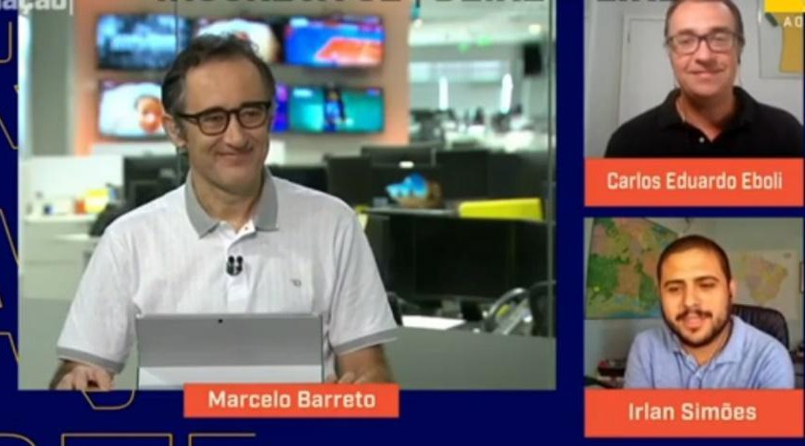
An example of a situation where the presenter has already returned to the studio, but the commentators are still at home and participate via their own devices.
Note: Redação SporTV, October 14, 2020.

Despite the increased demands and require- ments, the company did not provide addition- al training for journalists, limiting itself only to the team that operated the Cloudcast soft- ware from a technical point of view. Presenter Marcelo Barreto states this in an interview for this paper:
That was the most important thing: having the program (software), know- ing that it worked and developing peo- ple within the company who were ca- pable of using it, solving any eventual problems [...] Then a technical team specialized in managing the Cloudcast was formed, and that is when Redação got the green light to go on air. (M. Bar- reto, personal statement, 29 Decem- ber 2020)
The analysis of this situation reveals contradic- tory aspects of convergence. Journalists had to use technological resources related to the In- ternet but adapted for television in an attempt more of emergency substitution than tech- nological convergence. Something that only evolved subsequently.
At a certain point, when television thought the pandemic was going to last longer, they distributed a kit to the principal people broadcasting from their homes, principal in terms of frequency and not in terms of impor- tance. So, they went to each of these people’s houses; I was one of them, with a tripod, a light - a single light, the one that looks like a halo, big - head- phones, and a microphone. This signif- icantly improved the quality of every- one’s transmission. (S. Xavier Filho, personal statement, 29 May 2023)
Despite this, the process can be considered successful, as SporTV managed to stay on the air and continues to achieve high levels of view- ership. It is important to note that this process also led to changes that continued into the post-pandemic period:
The need to have a studio in my home led me, of course, to acquire skills that I did not have. I improved a lot, a lot [...] and I think, for other people, who were more dependent on third parties
- my colleagues - maybe the evolution, the need, has brought about an even bigger transformation. (S. Xavier Filho, personal statement, 29 May 2023)
  - There was a reduction in the num- ber of professionals involved in the production, recording, and broadcast- ing processes during the pandemic. A demand previously met by more people was met by fewer, with signs of convergence, especially from a techno- logical and professional point of view.

This hypothesis arises as a consequence of the previous one and is confirmed. There was a reduction in the number of people involved in journalistic processes at the SporTV channel during the pandemic, with professionals taking on multiple roles. This demonstrates aspects of the technological convergence mentioned above, as well as professional convergence: “The pandemic accelerated a process that was already underway, of simplification and cost reduction [...] we became everything, cameras, lighting, and much more”(S. Xavier Filho, per- sonal statement, 29 de mayo de 2023).
As mentioned above, this reality did not mean improving quality or maintenance. Still, it was a sufficient resource to guarantee the continuity of activities on the SporTV channel in an entire- ly atypical moment.
The most significant difficulties were really when there were technical prob- lems, either with the platform or persis- tent problems with those participating in the program, including myself, who sometimes had connection problems when working from home. In most cas- es, we were able to disguise it, but on some occasions, the commentators had to assume and say that I would be back at any moment. (M. Barreto, per- sonal statement, 29 December 2020)
From the perspective of professional conver- gence, it is also relevant to highlight an aspect Barreto (2020) pointed out that indirectly refers to the proof of this hypothesis: sports journal- ists also had to work in other areas unrelated to sports. The presenter reveals that many SporTV
professionals were assigned to other Globo Group stations to work in general news pro- duction. At the same time, the topics covered by Redação SporTV also transcended sports is- sues. Patatt (2021) detailed that the program addressed subjects such as politics and public health, sometimes even more than the sport it- self, in several editions. In an interview for this work, Marcelo Barreto corroborates this:
In terms of dealing with issues relat- ed to the pandemic, this is in line with what I often say, that the sports jour- nalist must be prepared to be a jour- nalist at some point, not just a sports journalist. And this was an interesting challenge we faced during the Redação Home Office period. It required us to be more informed about an area that is not necessarily our area of exper- tise, and I think, above all, it demanded a lot of responsibility in talking about the return or not of football and other sports. We were dealing with a broad- er topic, which was a topic of interest to society (M. Barreto, personal state- ment, 29 December 2020).
Despite all these factors, Xavier Filho (2023) assures that he did not feel overwhelmed but that not all professionals had the same capac- ity to adapt. According to him, some found it more challenging to cope with the accumula- tion of tasks, especially those used to a televi- sion structure with well-defined roles. Although the quality of productions has been reduced, as detailed in Patatt (2021), the journalist does not consider this a problem:

When you analyze broadcasting and content reception, you realize that those who receive the content are also in a difficult situation; they are also in an emergency, they know that their life has less quality because of the limita- tions of not being able to go outside, due to the confinement itself. (S. Xavi- er Filho, personal statement, 29 May 2023).
The journalist also states that those with pro- fessional experience marked by versatility, with passages through different media and who are “intimate with radio, audio, video, writing” (S. Xavier Filho, personal statement, 29 May 2023) have made a difference.
This statement fully aligns with technological, professional, and business convergence ideas. The latter is especially evident in the confirma- tion of the third hypothesis of this work.
2) The integrated newsroom, where professionals from different media of the same group worked in the same place, was decisive in overcoming some difficulties during the COVID-19 pandemic, as well as the ability to op- erate in a remote newsroom system in the online context.
According to Grupo Globo’s sports editor Gus- tavo Maria, who took over the position in 2018, before the pandemic, there was already a structure linking different media outlets of the Brazilian media conglomerate:
“ [...] an integrated structure that works for SporTV, TV Globo, and GE.globo. Our newsroom in Rio has approxi-
mately 400 professionals [...] SporTV’s main newsroom is in Rio de Janeiro, where the channel’s studios are locat- ed. And, consequently, where the pre- senters, editors-in-chief, and most of the narrators and commentators are located. But there is also a large news- room in São Paulo and newsrooms in Belo Horizonte, Recife, and Brasilia.” (G. Maria, personal statement, Febru- ary 11, 2022).
That said, it is possible to consider that the above structure influenced the journalistic out- put during the pandemic. The analysis carried out in this paper found that, except for the first two programs recorded during the first interval that did not even have an image for illustration, in the rest (representing 90% of the total), at least one media outlet of the Globo Commu- nications Group, which shares the same news- room as SporTV in an integrated manner, was mentioned. Its content was used during the Redação Home Office period.
According to Maria (2022), acting convergently was essential to meet these needs, not only for the program mentioned above but also for the information channels of the entire conglomer- ate:
Integrated work develops more com- plete professionals with a multi-plat- form vision, more prepared for the present and the future. Being together was very important during the pan- demic. The integration of the struc- tures allowed us to have a broader vision of the team and a more efficient distribution of our workforce. And,

amid so many absences, we always managed to deliver relevant content to our consumers, whether on digital, cable or broadcast TV. (G. Maria, per- sonal statement, February 11, 2022)
The fact that newsrooms had been integrated since before the pandemic was also consid- ered by Maria (2022) to be fundamental during the Redação Home Office period. According to Barreto (2020), this occurred when most peo- ple, including editors-in-chief and executives, worked from home, with few exceptions for op- erationally indispensable professionals:
The pandemic made us discover the possibility of working from home [...] then we developed a hybrid model. The functions that need to be in the newsroom, in the editing rooms, in the studios, and on the street work in per- son. Those who can work from home have a staggered schedule. They go to the newsroom once a week. Since then, the newsroom has never been at 40 percent of its capacity. (G. Ma- ria, personal statement, February 11, 2022)
In other words, the situation of remote work- ing as part of the convergence process related to the restructuring of newsrooms also stands out, and as seen here, not only in the case of Redação SporTV or the SporTV channel but in the entire unified newsroom of Globo Commu- nications Group, which is significant.
However, it cannot be affirmed that the inte- grated work has been entirely practical, accord- ing to Xavier (2023):
Because of cultural differences, we never managed to have a seamless integration where you could produce something for one side and quickly understand that you needed to send it to the other. That does not happen organically. You always need some su- pervisor or boss to come along and say: “Hey, why don’t you put this in GE? So, it is a partial integration, which I think has not quite worked yet. It has a bit of a mirage that works perfectly, but I think it does not work because it was not born that way. (S. Xavier Filho, personal statement, 29 May 2023)
Once again, the need for communication professionals to adapt to different roles, net- working - remote or face-to-face - and the re- adjustment of formats are highlighted as char- acteristics of convergence in journalism.
4) The difficulty of producing new con- tent with the audiovisual characteris- tics of television due to factors such as the lack of training and sporting com- petitions and the need for social dis- tancing accelerated the convergence of content.
This hypothesis can be considered only partial- ly true.
There is a convergence of content insofar as in- teractivity was present in both intervals analyz- ed: comments sent by viewers via Twitter, using the hashtag #RedaçãoSporTV, were used both

during the period of remote work and the re- turn to the studio.
On the other hand, the finding follows what Patatt (2021) presented regarding the use of journalistic productions from other media. More of a content remediation than a true con- vergence was observed. The first two episodes of Redação Home Office did not feature the use of any television journalism format. The similar- ity was instead a conversation transmitted on the internet.

Figure 2
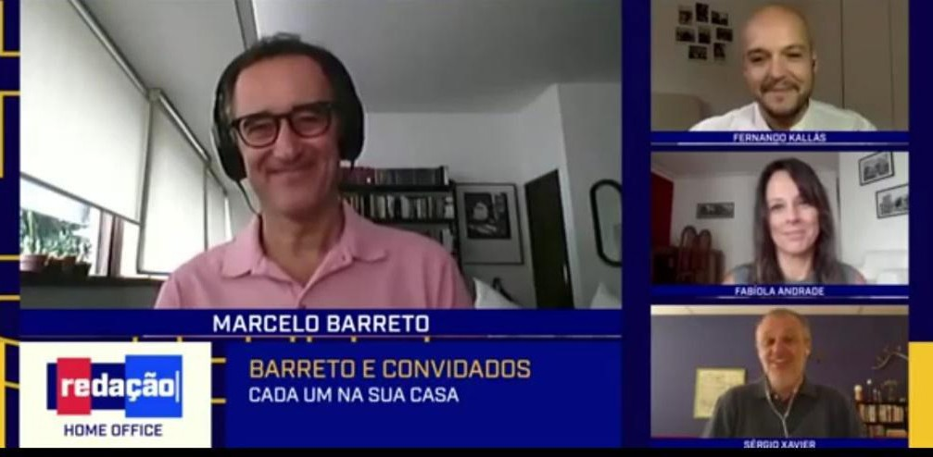
An example of how the first Redação Home Office was presented.
Note: Redação Home Office, March 30, 2020.

All the other programs in both intervals had im- ages to illustrate some interventions, but dur- ing Redação Home Office, the final product had no unique features. The material was redistrib- uted on a different platform. For example, the front page of a newspaper was shown, read, and commented on without necessarily adding particular attributes of television.

Figure 3
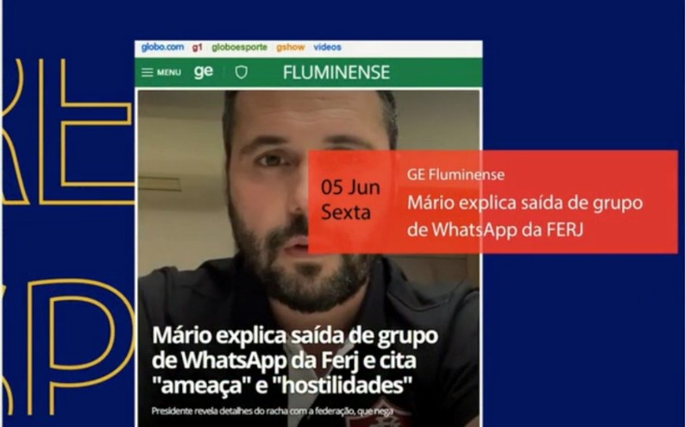
Example of content remediation
Note: Redação Home Office, June 05, 2020.
According to Sérgio Xavier Filho, there was a great closeness of social networks, not only in the Redação SporTV program or in the Redação Home Office, but in the SporTV channel in gen- eral, mainly when it resorted to rebroadcasting old football matches to keep the programming on the air.
Empezamos a hablar de cosas an- tiguas, como la final de la Copa del Mundo de 1970 [...] eso es algo pro- pio de los aficionados de YouTube, que van y buscan contenido antiguo y lo disfrutan, luego van y buscan otro... Creo que, de alguna manera, debido a las limitaciones, también nos converti- mos un poco en eso. Nos convertimos en un gran YouTube en ese sentido, transmitiendo contenido que no es necesariamente contemporáneo. (S. Xavier Filho, comunicación personal, 29 de mayo de 2023)
The journalist also highlights other media char- acteristics that were not previously part of the Redação SporTV program.
[...] it is a resource that we did not really use, the text, the quotes in the middle of the screen, starting to use more images from the social networks themselves and even a ‘tiktokisation’5 of our journalism. It left some marks, but something stayed for now; I think we continue with these new possibil- ities, which are used much more fre- quently than before the pandemic. I do not think it is necessarily a bad thing. (S. Xavier Filho, personal statement, 29 May 2023)

  - Refiriéndose a red social TikTok.

It is possible to use social networks as an ex- ample of content remediation; the showing of a clip of Grupo Globo collaborators made from a trend on the digital social network TikTok, which was shown in its entirety at the program’s opening and without any alteration whatso- ever. These changes are evident, for example, from the screen format: it was recorded entire- ly vertically, as was the content of TikTok, which is not in line with standard television practice.

Figure 4
Content for TikTok reproduced in full in Redação Home Office
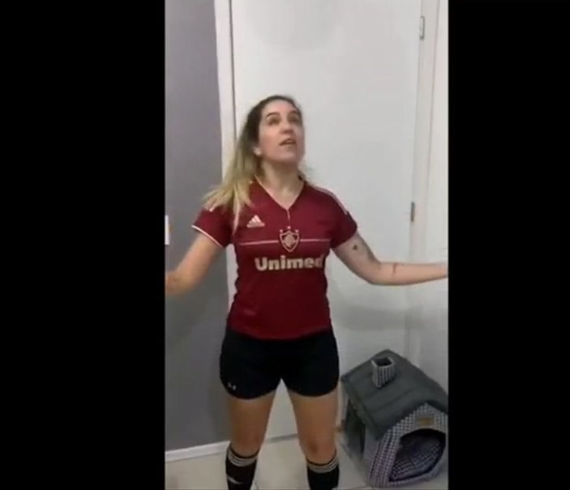
Note: Redação Home Office, April 28, 2020.

It is possible to say that remediation was a way of meeting a need that, at the time, could not be envisaged in any other way.

CONCLUSIONS AND DISCUSSION
The convergence presented by the Brazilian channel SporTV was not thoroughly thought out and structured but was carried out in an emergent way. Even so, it was efficient, as it al- lowed, in general terms, the integration of tools, workspaces, and languages for the benefit of live sports programming.
Even at a time without training or competitions, when there was no possibility of developing themes due to the need for social distanc- ing imposed by the COVID-19 pandemic, the Redação SporTV program managed to fulfill its role of informing its audience.
The multimedia skills of the professionals, to- gether with the general vision of journalism not only from the sports perspective, were funda- mental aspects in realizing the journalistic ac- tivities in the SporTV channel.
In terms of integrated newsroom, it can be considered, according to the different points of view presented in the interviews, that there would be a greater ease of work if there were a complete integration with a multiplatform infra- structure controlled by a central news system and a single management of the news flow. It is not enough to have connections that occur through the intervention of multimedia coordi- nators or certain collaborative routines.

The fact that Redação SporTV has the charac- teristics of a content aggregator, also acting based on information published in other me- dia, facilitated the work during the pandemic. However, it is considered that it would have been possible to serve in a more convergent way, not only replicating this information but with unique characteristics of each product and in an indeed televised language.
That said, and considering the prominence of the sample for the reasons already mentioned. However, it is a case study; it is possible to af- firm that journalistic convergence was funda- mental to developing television sports journal- ism in Brazil during the COVID-19 pandemic.
This is in line with what has been found in oth- er countries, according to the literature, espe- cially about the use of content, the structure of newsrooms, the usage of television formats from other media, the need for journalists to
be “multidisciplinary” - not only from a techno- logical perspective but also in terms of the ne- cessity to address issues more broadly - as well as new forms of news distribution and work on multiple platforms.
Although there are several studies on the sub- ject in Brazilian media companies, the specific focus on the pandemic with all its controver- sial situations shows how convergence made a difference in a time of such crisis. After all, it is more difficult to imagine and implement new communication models under pressure.
An acceleration of the convergence process has been observed, and the questions to be asked now concern the future implications of these emergency measures and parallel situa- tions in other media companies to obtain more definitive comparisons.

REFERENCES

Batista, E.C., Matos, L.A. & Nascimento, A.B. (2017). A entrevista como técnica de investigação na pesquisa qualitativa. Revista Interdisciplinar Científica
Aplicada, 11(3), 23-38. https://portaldeperiodicos.animaeducacao.com. br/index.php/rica/article/view/17910.
Boyle, R. (2017). Sports Journalism: Changing Journalism Practice and Digital Media. Digital Journalism 5(5), 493–495. https://doi.org/10.1080/21670
811.2017.1281603
Bradshaw, T. (2020). Sports journalism should toy with some different ideas. In J. Mair, The Virus and the media. How journalism covered the pandemic. Bite-sized Books. https://eprints.glos.ac.uk/8443/1/8443-Bradshaw-
(2020)-Sports-journalism-should-toy-with-some-different-ideas.pdf.
Canavilhas, J. (2012). Da remediação à convergência: um olhar sobre os me- dia portugueses. Brazilian Journalism Research, 8(1), 7-21. https://doi. org/10.25200/BJR.v8n1.2012.369
Canavilhas, J., Satuf, I., Luna, D., & Torres, V. (2015). Jornalistas e tecnoa- tores: dois mundos, duas culturas, um objetivo. Esferas, (5). https://doi. org/10.31501/esf.v0i5.5690
Canavilhas, J., Satuf, I., de Luna, D., Torres, V., Baccin, A., & Marques, A. (2016). Jornalistas e tecnoatores: a negociação de culturas profis- sionais em redações on-line. Revista FAMECOS, 23(3), . https://doi.
org/10.15448/1980-3729.2016.3.24292
Carvalho, P. (2023). SporTV registra audiência histórica e vive melhor abril des-
de o início da pandemia. Retrieved 25 May 2023, from https://rd1.com. br/sportv-registra-audiencia-historica-e-vive-melhor-abril-desde-o-ini- cio-da-pandemia/
Casero-Ripollés, A. (2020). Impact of Covid-19 on the media system. Com- municative and democratic consequences of news consumption during the outbreak. El profesional de la información, 29 (2) https://doi.
org/10.3145/epi.2020.mar.23
Deuze, M., & Witschge, T. (2017). Beyond journalism: Theorizing the transformation of journalism. SAGE Journals. http://doi.org/10.1177/1464884916688550
Fechine, Y. (2001). Gêneros televisuais: a dinâmica dos formatos. Revis- ta Symposium, 5(1), 14 – 26. http://www.maxwell.lambda.ele.pucrio. br/3195/3195.PDF.
Ferrucci, P., & Perreault, G. (2022). Local is now national: The Athlet- ic as a model for online local news. New Media & Society. https://doi. org/10.1177/14614448221117748

Fonseca Júnior, W. (2006). Análise de Conteúdo. En A. Barros & J. Duarte (Ed.), Métodos e Técnicas de Pesquisa em Comunicação (pp. 280-304). Atlas. García-Avilés, J. A. (2021). Journalism as usual? managing disrup- tion in virtual newsrooms during the COVID-19 crisis. Digital Journal- ism, 9(9), 1239–1260. https://doi.org/10.1080/21670811.2021.19421
12
García-Avilés, J. A. (2021). Journalism as usual? managing disruption in virtual newsrooms during the COVID-19 crisis. Digital Journalism, 9(9), 1239– 1260. https://doi.org/10.1080/21670811.2021.1942112
Gil, A. (2008). Métodos e técnicas de pesquisa social. Atlas.
Götz, C. & Costa, C. (2021). O impacto da pandemia de covid-19 nas roti- nas dos departamentos de esportes das rádios Guaíba, Itatiaia, Super Tupi e Bandeirantes. Tropos: Comunicação, Sociedade e Cultura , 10(1).
https://periodicos.ufac.br/index.php/tropos/article/view/4646.
Mair, J. (2020). The virus and the media: How journalism covered the pan- demic. Bite-Sized Books.
Memória Globo (2021). Copa do Mundo da Espanha – 1982. Recuperado el
25 de Mayo de 2023 en https://memoriaglobo.globo.com/esporte/ copa-do-mundo-da-espanha-1982/noticia/copa-do-mundo-da-es- panha-1982.ghtml
Morisson, S. (2014). The Toy Department Shall lead us. Columbia Journalism Review. https://archives.cjr.org/reports/the_toy_department_shall_lead. php
Mosby J. (2020, 14 de septiembre). A world without sports: How sports jour- nalists are handling the pandemic. The Daily Egyptian. http://www.dai- lyegyptian.com/102333/sports/a-world-without-sports-how-sports-
journalists-are-handling-the-pandemic/.
Olsen, R. K., Pickard, V., & Westlund, O. (2020). Communal News Work: Cov- id-19 calls for collective funding of Journalism. Digital Journalism, 8(5), 673–680. https://doi.org/10.1080/21670811.2020.1763186
Patatt, C. (2021). O telejornalismo esportivo brasileiro durante a pandemia de COVID-19: uma análise ao programa redação SporTV. In D. Gui- marães, F. Giacomelli, L. Margadona, J. Barcellos & J. Marques, Instantes
revelados: da fotografia ao esporte (1st ed., pp. 302-336). Ria Editoral. Retrieved 16 February 2022, from http://www.riaeditorial.com/index. php/instantes-revelados-da-fotografia-ao-esporte/.
Patatt, C. (2023). COVID-19: a produção multimídia dos clubes de futebol como recurso para os canais de televisão. Comunicação Pública, 18(34). https://doi.org/10.34629/cpublica.736
Patatt, C. & Rocha, F. (2020). Jornalismo Em Tempos De COVID-19: o fact-checking no Brasil e em Portugal durante os 90 primeiros dias da pandemia. Revista GEMInIS, 11 (2), 67-80. https://www.revistageminis.
ufscar.br/index.php/geminis/article/view/503/380

Perreault, G. & Nölleke, D. (2022). What is sports journalism? How covid-19 accelerated a redefining of U.S. Sports Reporting. Journalism Studies, 23(14), 1860–1879. https://doi.org/10.1080/1461670x.2022.2117237
Salaverría, R. (2003). Convergencia de los medios. Revista Latinoamericana de Comunicación CHASQUI, 81, 32 – 39. https://comunicacion3unlz. com.ar/wp-content/uploads/2015/09/Convergencia-de-los-medi-
os-Ram%C3%B3n-Salaverr%C3%ADa.pdf
Salaverría, R. (2010). Estructura de la Convergencia de Medios. En X. Lopez & X. Pereira (Ed.), Convergencia Digital: Reconfiguración de los Medios de
Comunicación en España (pp. 27-40). Servizo de Publicacións e Inter- cambio Científico.
Salaverría, R., Avilés, J., Masip, P. (2010). Concepto de Convergencia Periodísti- ca. https://dadun.unav.edu/bitstream/10171/23730/1/cap3_concep- to_de_convergencia_periodistas_pp41-64.pdf
Schallhorn, C. & Kunert, J. (2020). Football without football: Creativity in Ger- man football coverage by TV broadcasters and clubs during the Coro- navirus Crisis. International Journal of Sport Communication, 13(3), 514-
522. https://doi.org/10.1123/ijsc.2020-0234
Vaquer, G. (2020). SporTV termina 2019 como canal de TV paga mais visto no Brasil; Grupo Globo emplaca 4 canais no Top 5. Recuperado el 25 de Mayo de 2023 en https://observatoriodatv.uol.com.br/audien-
cia-da-tv/sportv-termina-2019-como-canal-de-tv-paga-mais-visto-no- brasil-grupo-globo-emplaca-4-canais-no-top-5
Yin, Robert (2005). Estudo de caso: planejamento e métodos. Bookman.

