Fencing on Instagram: Examining self-presentation as branding strategies of professional fencers
Esgrima en Instagram: examinando la autopresentación como estrategia de marca de los esgrimistas profesionales
3
ARTICLE

Admilson Veloso da Silva
Corvinus University of Budapest

Admilson Veloso da Silva is a Brazilian Journalist with a MA in Social Communication and is currently pursuing his Ph.D. in Communication Science at the Corvinus University of Budapest, Hungary. He also lectures at the Institute of Marketing and Communication Sciences at the same university. His main research areas are social media studies, Instagram, visual mobile communication, and online self-presentation.

veloso@uni-corvinus.hu
ORCID: https://orcid.org/0000-0001-9167-3902

Tao Yiming
Corvinus University of Budapest

Tao Yiming has a Bachelor’s degree in Communication and Media Science from the Corvinus University of Budapest and is passionate about fencing and sport communication. He dedicated part of his life to the professional practice of fencing and now aligns it as a hobby with the study of how athletes can use branding to improve the sport’s image.

yimingtao397@gmail.com
ORCID: https://orcid.org/0009-0009-1326-4930 RECEIVED: 2023-05-25 / ACCEPTED: 2023-09-12

51
OBRA DIGITAL, 24, December 2023, pp. 51-71, e-ISSN 2014-5039 DOI: 10.25029/od.2023.384.24
51

Abstract
Instagram has impacted how athletes present themselves and communicate with their audi- ences without the need for mass media me- diators, such as journalists. Hence, this study explores the opportunities for professional fencers to develop self-presentation and com- munication strategies on the platform. The methodological approach is based on netnog- raphy and content analysis, evaluating the top 10 fencers accounts (FIE). The findings point out how these athletes build their brand by increasing fan engagement and interaction through sharing training videos, competition photos, and personal stories, while also collab- orating with sponsors and brands to open up business opportunities and revenue streams. Therefore, fencers’ active use of Instagram en- hances their self-presentation and positively in- fluences the image of fencing as a sport.
KEYWORDS
Sport communication, social media studies, In- stagram, athletes branding, fencing
Resumen
Instagram ha impactado la forma en que los atletas se presentan y se comunican con sus

INTRODUCTION
The accessibility of athlete-related informa- tion has significantly increased through news websites since the 1990s, with contemporary sport communication providing an overview of their training and competitions. Howev- er, much of this content is ‘media-processed,’ capturing fleeting moments rather than pre- senting a comprehensive view of athletes’ lives (Ma, 2021). More recently, the advent of social media platforms enabled athletes to express their thoughts and experiences in a more au- thentic and relatable manner (Kutzer, 2016).
audiencias sin la necesidad de mediadores de medios masivos, como los periodistas. Por lo tanto, este estudio explora las oportunidades para que los esgrimistas profesionales desa- rrollen estrategias de autopresentación y co- municación en la plataforma. El enfoque meto- dológico se basa en la netnografía y el análisis de contenido, evaluando las cuentas de los 10 mejores tiradores (FIE). Los hallazgos señalan cómo estos atletas construyen su marca al au- mentar el compromiso y la interacción de los fanáticos al compartir videos de entrenamien- to, fotos de competencias e historias persona- les, al mismo tiempo que colaboran con patro- cinadores y marcas para abrir oportunidades comerciales y fuentes de ingresos. Por lo tanto, el uso activo de Instagram por parte de los es- grimistas mejora su autopresentación e influye positivamente en la imagen de la esgrima como deporte
PALABRAS CLAVE:
Comunicación deportiva, estudios de redes so- ciales, Instagram, atletas branding, esgrima.

Instagram, in particular, offers them a unique visual-centered way that bypasses traditional media and provides the public with a broader perspective. Hence, this study has the objective of exploring the opportunities brought by the platform to professional fencers in develop- ing self-presentation as sport communication strategies, with a focus on personal branding.
The study’s relevance lies in its contribution to the field of sport communication and social media studies, besides its novelty in analyzing online branding strategies among a specific group of sportspeople. Despite the extensive

study of sport communication, fencing remains a less explored subject within this domain, pos- sessing unique characteristics that distinguish it from other sports. For instance, fencers com- pete with their faces covered, temporarily con- cealing aspects of their identity despite their names being printed on their outfits, thus part- ly limiting what the audience can see from the person. Additionally, Instagram has become one of the most popular visual social media globally, accounting for more than two billion active users in 2023 (Kemp, 2023), and its use has been investigated in other sports (Lobillo Mora and Aja Gil, 2020), but there is still a lack of scientific knowledge about its application for branding in fencing.
Furthermore, professional athletes hold a unique position as social and cultural influenc- ers, utilizing social media platforms to voice their opinions and impact not only specific topics or events but the broader society as well (Kutzer, 2016). Instances of sportspeople making pub- lic political statements or expressing opinions on social media have generated extensive dis- cussion and garnered attention from diverse sectors of society. Moreover, young sports fans and students often observe professional ath- letes on social media, seeking to learn from and emulate their healthy lifestyles, training meth- ods, and competitive attitudes.
To investigate this phenomenon, the authors adopt a methodological approach based on netnography (Kozinets, 2010) and content analysis (Krippendorff, 2018), focusing on eval- uating the top 10 fencers’ accounts from the International Fencing Federation (FIE). Moreo- ver, the study addresses two primary research questions: (RQ1) What are the sport commu- nication trends regarding professional fencers’ self-presentation on Instagram? (RQ2) How does the Instagram content of professional fencers affect the perception of fencing as a
sport? By examining how fencers portray them- selves on this platform, the study seeks to iden- tify the strategies and techniques employed to create a compelling personal brand that res- onates with their followers, while also shaping the perception of fencing as a whole.
The findings reveal that professional fencers encounter some opportunities offered by social media to interact with their audiences, share sport-related and behind-the-scenes footage, and promote their brand values. In this sense, the platform enables them to increase fan en- gagement and interaction by sharing training videos, photos of their competitions, and per- sonal stories that offer a glimpse of their daily lives to the public. Furthermore, collaborations with sponsors and brands open up addition- al business prospects and revenue streams. Therefore, Instagram enables these athletes to showcase their competitive spirit and their skill level to a larger audience, thereby attract- ing more individuals to participate in and follow the sport. In the next section, we present an overview of the literature regarding contem- porary sport communication, and social media, and explain relevant characteristics of fencing to the study.

THEORETICAL BACKGROUND

  - SPORT COMMUNICATION AS A DIVERSE PRACTICE
Sport communication studies have traditionally focused on analyzing media coverage of sports events, games, and athletes’ lives (Bernstein and Blain, 2002; Abeza et al., 2014; Hambrick, 2017). However, since the emergence of the In- ternet, particularly social media like Instagram, professional athletes, and other sportspeople have been able to reach and engage a far big-

ger audience than previously (Kutzer, 2016). Bernstein and Blain (2002) noted that “sport and the media have become associated to such an extent that it is often difficult to discuss sport in modern society without acknowledging its relationship with media” (p. 3).
Since 1980, sport communication research and practice has experienced significant growth, with this professional activity being recognized as one of the four functions of sport manage- ment (Hambrick, 2017). Scholars have studied the role of communication within the realm of sports, which is evident through the emer- gence of new textbooks, journals, associations, and conferences dedicated to sport commu- nication, facilitating the dissemination of ideas and fostering advancements in the field (Abeza et al., 2014).
According to Pedersen et al. (2007) and Billings (2016), sport communication is a dynamic pro- cess through which individuals engage in the sharing of symbols and create meaning within the context of sports. It encompasses a diverse set of activities, including observing and analyz- ing meaning-making processes, managing and directing communication, and exploring the im- pact of sports on individuals and society. This results in an interplay of roles, since there are at least three areas in which sport communica- tion exists in the sports industry. Namely:
First, sport communication is communication in sports;
Second, sport communication is communica- tion in a sport setting;
Third, sport communication is communication through sport.
Furthermore, people participating in sport communication may serve as both senders and receivers of messages, as these two spectrums are not always separated. For example, within
media organizations, senders could consist of sports editors, producers, journalists, broad- casters, and other personnel involved in con- tent production, while the receivers are their audience (e.g. listeners, viewers, readers, etc.), customers, advertisers, and any individual or group responsible for interpreting sports-relat- ed information (Pedersen et al., 2007). Howev- er, sports fans expressing discontent with their team’s performance also act as senders whose message could affect these relationships (e.g. influence changes in the team management).
As outlined above, the sport communication process involves multiple components such as sports institutions, media, spectators, and other entities associated with the sports envi- ronment. Furthermore, Pedersen et al. (2007) argue that sport communication can be in- tentional or unintentional, complex, cyclical, irreversible, transactional, irreducible, dynam- ic, multidimensional, and encompasses both verbal and non-verbal aspects. In this context, Wenner (2017) suggests that communication plays a relevant role in shaping the social power and cultural significance of sports. In the follow- ing section, we explain how sport communica- tions intersects with social media.

SPORT COMMUNICATION AND SOCIAL MEDIA BRANDING
Social media is defined as “a set of Inter- net-based applications that are built on Web
2.0 ideas and technologies and allow the crea- tion and exchange of user-generated content” (Kaplan and Haenlein, 2010, pp. 59-58). As a functional definition, it refers to the interaction between people and also to the creation, shar- ing, exchange, and commenting of content in virtual communities and networks (Toivonen, 2007). Among the most popular social media platforms nowadays, Instagram accounts for

over two billion users in 2023 (Kemp, 2023), impacting how we communicate, share, and consume content online (Veloso, 2021). Since its launch in October 2010, Instagram has seen rapid growth in the number of users and up- loads (Hu et al, 2014), providing users with an instant way to share moments of their lives with friends through a series of (filtered) images and videos (Veloso, 2018), thus having a strong visual focus (Serafinelli and Villi, 2017).
Not surprisingly, social media have become popular tools for sport communication (Hutchins, 2011; Sanderson, 2011) and differ from traditional media in at least two ways: They are not resource-limited by time (broad- casting) or print space (newspapers). Hence, these platforms, more specifically Instagram, offer an abundance of content and play an important role in the delivery of multimedia messages to sports audiences (Romney and Johnson, 2020a), while enabling interperson- al and mass communication spaces that can increase audience engagement (Romney and Johnson, 2020b). Espinosa (2021) indicates that the emergence of social networks has given rise to a distinct form of communication, char- acterized by rapid conversations and effortless transmission of information (p. 11).
For Meraz (2009), social media are ‘‘architect- ed by design to readily support participation, peer-to-peer conversation, collaboration, and community’’ (p. 682). Since sports are by na- ture a highly visual exercise, with images of ath- letes capturing excitement, effort, and emotion (Romney and Johnson, 2020a), the integration of visual platforms such as Instagram into sport communication seems a strategic choice. Pro- fessional athletes from all fields already take advantage of these online opportunities. This is especially important for those who do not receive daily mainstream media coverage to generate publicity, as social media provides a
promotional vehicle to raise awareness and build their personal brand (Eagleman, 2013; Parmentier & Fischer, 2012).
A study of MotoGP pilot Jorge Lorenzo on Ins- tagram, conducted by Lobillo Mora and Aja Gil (2020), has pointed out nine main topics being covered in the user’s content during the season 2018, but with a prevalence of posts related to competition (25%) and training (25%). The pi- lot’s personal life (11%), endorsement and sponsorship (11%), and other miscellaneous topics (10%) appeared in the sequence. Less prevalent themes included declarations (7%), recognition of other public figures (6%), lesions (3%), and season summary (2%). The authors also show that 73% of the posts covered dis- cussions related to the pilot’s career and activ- ities that may influence it (p. 111). Finally, the research on Lorenzo’s Instagram reveals that he primarily used single images for quick con- sumption, focusing on his professional identity as a pilot, while adding English in short, simple descriptions.
Benavides et al. (2021) surveyed 2,410 people in Santiago de Chile to evaluate the social per- ceptions of the Chilean National soccer team as a brand. The authors point out that the national team holds a strong brand image and is highly regarded by the majority of Chileans. Despite differences among socioeconomic groups and age ranges, the overall evaluation of the team and the emotions it evokes are positive, con- trasting with the perception of the country it- self. Older generations may have a more pessi- mistic outlook based on past experiences, while younger individuals tend to be more optimistic due to recent victories. Moreover, the national team is seen as a unifying force in Chilean so- ciety, promoting good coexistence and serving as role models.

Previous studies (Poletti, 2011) have also demonstrated that the process of sharing nar- ratives on social media platforms contributes to ‘intimacy’ and ‘community bonds’ between the communicator and the audience (p. 76). Moreover, researchers have examined how In- stagram can be used to engage fans for sport- ing, business as well and social purposes (Kim and Hull, 2017); as a self-presentation tool by Olympic athletes in specific (Geurin-Eagleman and Burch, 2016), or by professional athletes more in general (Smith and Sanderson, 2015). The public’s perception of an athlete is relevant to their career as it can also influence the ath- lete’s endorsements and contract negotiations.
Historically, their self-presentation was con- strained by the influence of mass media, rely- ing heavily on how sports journalists portrayed them. However, athletes now have more con- trol over the dissemination of information and can showcase aspects of their identity that they consider most important, enabling a more per- sonalized and authentic representation. In this scenario, the term “athlete brand” is defined by Arai et al (2013) as “a public persona which has already established their own symbolic mean- ing within their name, face, or other elements in the market” (p. 391).
To better understand the key components of athlete brands, Arai et al., (2013) developed a conceptual Model of Athlete Brand Image (MABI), which outlines how athlete brands are a cumulative result of how they are perceived in both frontstage and backstage settings. The MABI specifically posits that consumer percep-
tions of athlete brands are influenced by per- ceptions related to:
- Athletic Performance

- Attractive Appearance

- Marketable Lifestyle
“Athletic performance” refers to an athlete’s on-field characteristics and athletic expertise, which play a relevant role in building their brand image and differentiating them from other athletes. “Attractive appearance” involves showcasing an athlete’s physical attributes, such as hairstyles, tattoos, body attributes, and muscle forms. Finally, “Marketable lifestyle” en- compasses an athlete’s off-field interactions with fans and activities outside of sports, their life story, allowing them to connect with their audience and share aspects of their personal lives.
Consumers’ perception of an athlete’s brand is influenced by the information surrounding the sportsperson, including their own brand management and self-presentation strategies (Walsh and Williams, 2017). The process re- quires them to emphasize their uniqueness during the promotion, and it can be achieved through their on-the-field performance and off- the-field activities (Lobpries et al., 2018). There- fore, effective branding strategies can provide athletes with added value, extended job mar- kets, and increased income through endorse- ment (Arruda and Dixson, 2007; Mogaji et al., 2020; Na et al., 2020).

Figure 1
MABI by Arai et al.
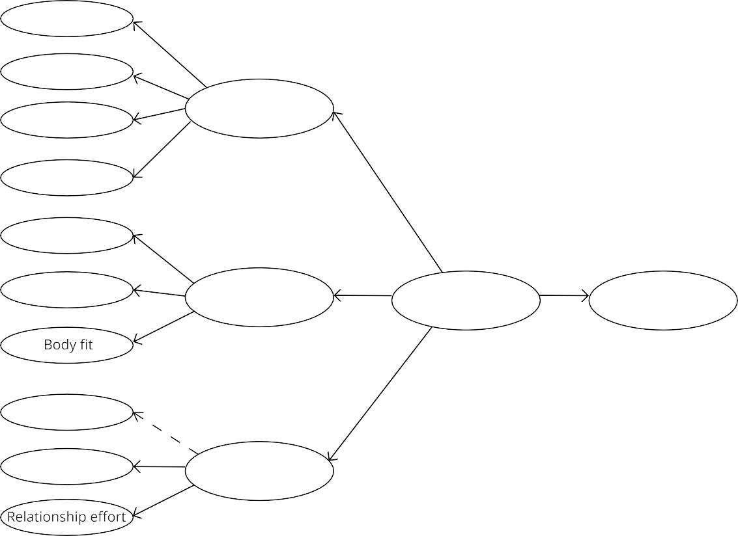
Athletic expertise
0.71
Competition Style
0.92
Sportsmanship 0.70 Athletic performance
0.80
Rivalry
0.77
Physical attributes 0.77
Symbol
0.97 Attractive appearance
0.57
0.47
Athlete«s brand image
0.59
Psychological commitment
0.89
Life story
0.14
Role model
0.91
Marketable lifestyle
0.93
Note: Conceptual Model of Athlete Brand Image (MABI) by Arai et al. (Source: Arai et al., 2013, p. 397).

FENCING: SPECIAL FEATURES
Fencing is one of the oldest sports, having that has evolved with the development of new met- al forging techniques, military training, and the influence of different cultures (Porzio and Mele, 2002). Throughout history, fencing has even been considered an art form (Labat, 1696); in 1604, it was officially introduced as a discipline (Agrippa, 1604), and in 1896, it became part of the Olympic Games held in Athens. Although it is not particularly dangerous, there is only a thin line between a fatal injury and a sim- ple knife wound. For this reason, fencers are required to wear a standard fencing uniform, masks, gloves, and socks while competing, and

must wear them throughout the competition (except during the prescribed breaks between matches).
Fencing is a martial sport characterized by skill- ful movements and non-contact between ath- letes and international fencing competitions can last several hours, but the actual match time comprises only a small portion, ranging from 17 to 48 minutes (Roi and Bianchedi, 2008). Be- cause it is a physically demanding activity, fac- tors such as age, gender, level of training, and tactical strategies employed against opponents influence the performance of fencers. Moreo- ver, the physical demands of fencing are closely intertwined with perceptual and psychological aspects, which evolve continuously throughout

a match based on the opponent’s behavior. The fencer must anticipate and deceive the op- ponent while maintaining mental and physical readiness to avoid lapses in concentration and fatigue (Roi and Bianchedi, 2008).
Furthermore, wearing a mask for safety also means that the fencer cannot show their face while competing, which makes the fencer ap- pear more mysterious to the spectators and also adds to the tension and spectacle of the competition, which is one of the special features of the fencer. Although their identity and emo- tions cannot be shown through facial expres- sions, fencers can still show their strength and even identity (e.g. signature moves) through their skills and movements during a match.
Beyond the competition venues and training settings, fencers can now demonstrate more of their personalities on social media platforms, such as Instagram. This represents a unique new aspect for fencers, as they unmask them- selves and can showcase other characteristics of their private life, building on sport commu- nication in a personalized way, which has not been vastly researched in communication sci- ence yet. In the following section, we explain the methodological approach used to collect data and analyze this phenomenon.

METHODOLOGY
The research relied on a multimodal method- ological approach based on netnography (Koz- inets, 2010) and qualitative content analysis (Al- len and Reser, 1990) for the data collection and analysis, thus offering an exploratory qualitative perspective that does not aim for generaliza- tion. We collected Instagram data (visuals only) from the top 10 men’s and women’s fencing (Epee) athletes worldwide for the 2021/2022 season, which was the latest consolidated ranking. The sample consisted of all their visual posts (photos and videos) published until April 30th, 2023 (N = 6.400) and the evaluation took place in the first four months of the year.
Netnography is a method inspired by tradition- al ethnography (Kozinets, 2010) that uses digi- tal data from the internet, such as web pages, forums, social media, etc., to study consumer behavior and social interactions. During the study, data was collected and analyzed from the fencers’ Instagram accounts, including their interactions with other users, content posted, number of followers, etc. This provided insight into the athletes’ self-presentation and interac- tion patterns. Additionally, Instagram was cho- sen due to its popularity, accounting for more than two billion active users (Kemp, 2023), and to the opportunity it offers fencers to share

multimedia content directly with their audienc- es in an easy way (mostly consumed mostly on mobile phones), bypassing editorial constraints that they could face in traditional media outlets.
Moreover, we applied a qualitative content analysis (Allen and Reser, 1990) to better un- derstand the brand image, attitudes, opinions, and marketing strategies of fencers, including images and videos. This process was achieved by manually analyzing the content posted on the platform and then categorizing and coding it according to the different post types.
As one of the most widely used analytical tools today, content analysis has been used fruitfully in a variety of research applications (Allen and Reser, 1990), and can be applied for quantita- tive or qualitative purposes. In this study, we developed a qualitative content analysis, which is defined as a research approach that involves the subjective analysis of data by systematically categorizing and identifying themes or patterns through a coding process (Hsieh and Shannon, 2005, p. 1278).
Through the initial survey of the 20 athletes (top 10 males and top 10 females), five out of 20 fencers set their accounts to private and, as their Instagram accounts are not highly vis- ible, the content was not included in the anal- ysis. The final list (Table 1) consists of 15 fenc- ers (Epee) who meet the following criteria: 1) Are ranked in the top 10 in the world for the 2021-2022 season; 2) had an open/public In- stagram account throughout the research pe- riod. Moreover, an additional in-depth analysis is provided with examples of the two athletes’ accounts with the highest number of followers.

Table 1
Fencers selected for the research
Name | Gender | Code | Instagram Account
CANNONE Romain | Male | H1 | www.instagram.com/romaincannone/
BOREL Yannick | Male | H2 | www.instagram.com/yannickborelofficiel/
LIMARDO GASCON Ruben | Male | H3 | www.instagram.com/rubenlimardo/
REIZLIN Igor | Male | Private | Omitted
KANO Koki | Male | H5 | www.instagram.com/kanokoki3568/
KOCH Mate Tamas | Male | Private | Omitted
BARDENET Alexandre | Male | Private | Omitted
KURBANOV Ruslan | Male | H8 | www.instagram.com/kurbanov_ruslan_13/
MINOBE Kazuyasu | Male | H9 | www.instagram.com/minobe_kazuyasu/
VISMARA Federico | Male | H10 | www.instagram.com/federicovismara/
CHOI Injeong | Female | Private | Omitted

SONG Sera | Female | M2 | www.instagram.com/sera.song/
KUN Anna | Female | Private | Omitted
CANDASSAMY Marie-Florence | Female | M4 | www.instagram.com/candassamymarieflorence/
FIAMINGO Rossella | Female | M5 | www.instagram.com/rossellina91/
KONG Man Wai Vivian | Female | M6 | www.instagram.com/vmwkong/
DIFFERT Nelli | Female | M7 | www.instagram.com/nellidiffert/
SANTUCCIO Alberta | Female | M8 | www.instagram.com/albertasantuccio/
NDOLO Alexandra | Female | M9 | www.instagram.com/alexandrandolo/
LEHIS Katrina | Female | M10 | www.instagram.com/katrinalehis/
Note: List of fencing athletes selected for the research

When analyzing the data, in addition to eval- uating each athlete’s account individually, we classified their publications according to four variables, based on previous analysis conduct- ed through the netnography. For this purpose, we coded each image (see Table 2) based on the activities they depicted, namely: Training and competition (T/C), daily life (DL), charity or volunteer campaign (C/VC), and athlete brand- ing or endorsement ads (A/E). It is important to note that this approach aimed for an initial exploration of their self-presentation strategies from a qualitative perspective, which we com- bine with examples from the athletes’ content. In the next section, we present the main results of our research.
Table 2
Coded content for each Instagram post per athlete

Ath- letes | T/C | DL | C/VC | A/E | Total posts
H1 | 52 | 43 | 2 | 16 | 113
H2 | 201 | 105 | 5 | 31 | 342
H3 | 348 | 563 | 40 | 55 | 1006
H4 | Privado | Privado | Privado | Privado | 0
H5 | 21 | 13 | 2 | 7 | 43
H6 | Privado | Privado | Privado | Privado | 0
H7 | Privado | Privado | Privado | Privado | 0
H8 | 18 | 53 |  | 1 | 72
H9 | 87 | 80 | 16 | 73 | 256
H10 | 34 | 30 | 1 | 1 | 66
M1 | Privado | Privado | Privado | Privado | 0
M2 | 30 | 51 | 1 | 2 | 84
M3 | Privado | Privado | Privado | Privado | 0
M4 | 58 | 59 | 3 | 9 | 129
M5 | 368 | 1499 | 35 | 231 | 2133
M6 | 53 | 157 | 57 | 27 | 294
M7 | 82 | 133 | 5 | 11 | 231
M8 | 126 | 460 | 0 | 5 | 591
M9 | 162 | 617 | 18 | 19 | 816
M10 | 127 | 78 | 4 | 15 | 224

Note: Classification of fencers’ posts per category in the content analysis

DATA ANALYSIS AND RESULTS

  - OVERVIEW OF TOP FENCERS ACTIVITY

ON INSTAGRAM
This section is weighted towards the following findings: Firstly, the data collection presenta- tion and interpretation of the netnography data from the Instagram accounts of the top 10 male and female fencing (Epee) athletes world- wide for the 2021/2022 season. Secondly, we provide a brief content analysis to reflect on the activities covered by their images. Finally, we evaluate these categories more in-depth and provide examples of the two most popular ath- letes on Instagram, based on the total number of followers.
Table 3 shows the number of followers and the number of publications from each of the top 10 male and female fencers (Epee) in the world for the 2021-2022 season. As can be observed in the data, the athletes have a very diverse activi- ty on the platform, with two females ranking as the most popular (F5 and F6) with more than 200,000 followers by the time of this analysis. Among the males, the most followed one (M3) had 75,000 people in their audience.
Furthermore, when comparing their number of posts, some of those with a larger follower base tended to share more often, which was the case for F5 (2.133 posts) and M3 (1.006 posts). However, other least popular accounts (e.g. F8 and F9) also maintained a frequent posting activity (591 and 816 posts, respective- ly), while the second most followed male (M1) had a significantly lower number of images
(113) when compared to the others. It is impor- tant to note that many factors can impact the amount of content shared on their accounts, such as when the profile was created and their intentions to publish daily activities. In addition, female athletes communicated more regularly on the platform than their male counterparts.
Table 3
Top 10 fencers’ activity on Instagram

Ath- lete | Follow- ers | Posts | Athlete | Follow- ers | Posts
H1 | 19.000 | 113 | F1 | Private | Private
H2 | 17.000 | 342 | F2 | 7.079 | 84
H3 | 75.000 | 1006 | F3 | Private | Private
H4 | Private | Private | F4 | 1.490 | 129
H5 | 3.026 | 43 | F5 | 300.000 | 2133
H6 | Private | Private | F6 | 207.000 | 294
H7 | Private | Private | F7 | 945 | 231
H8 | 991 | 72 | F8 | 8.651 | 591
H9 | 7.661 | 256 | F9 | 8.581 | 816
H10 | 1.605 | 66 | F10 | 9.071 | 224

Note: Fencers followers and posting activity on Instagram

Through the survey and analysis, we noticed that there is a positive correlation between the number of posts and the number of followers of professional fencers, suggesting that their self-presentation strategies on Instagram can attract more followers and potentially increase their personal brand value and influence. This also reflects the effectiveness of professional fencers’ use of Instagram as a sport communi- cation channel, which is likely to help increase the attention and awareness of fencing.
Figure 2
Types of posts on Instagram by gender

male
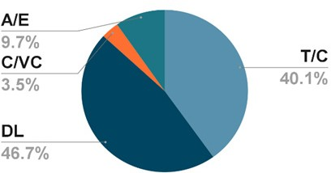

female

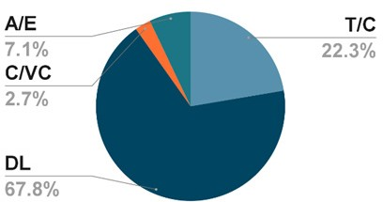

Note: Types of posts on Instagram by the top 10 male (left) and female (right) fencers
To further assess these strategies, we evaluat- ed the activities that these athletes covered in their Instagram content. As can be seen from Figure 2, the most frequent category was daily life (DC), which refers to visual information that depicts their experiences beyond sports set- tings and could be related to two dimensions of the MABI (Arai et al., 2013), namely “Attrac- tive appearance” and “Marketable lifestyle”. The representation of activities varies between gen- ders, with females sharing more of their quotid- ian (67.8%) than males (46.7%) in the analyzed sample.
Hence, the platform acts as a place where ath- letes use their accounts to share their private lives, depicting routine events, such as travel, food, beverages, recreational activities, etc. An example is shown in Figure 3, with fencers F6 photographed while enjoying ice cream in a garden and M1 in a home setting with casual clothing while holding a big fish. Compared to professional competition content, daily life posts are more relaxed, fun, and easy to inter- pret and, therefore more palatable for the gen- eral audiences.

Figure 3
Fencers’ daily life content

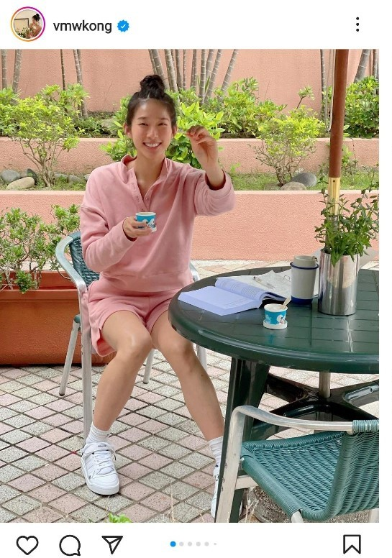
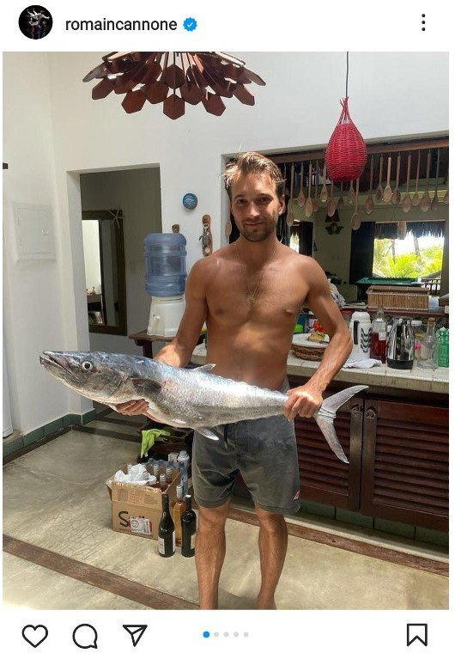
Note: Fencers F6 (left) and M1 (right) representing their daily life on Instagram. Source: Instagram/Screenshot
Training and competition events (T/C) only ap- pear in second place, but do not reach nearly the same proportion of daily life content, point- ing out a less prevalent use of the “Athletic per- formance” dimension from the MABI (Arai et al., 2013) among these athletes. Additionally, male athletes seem to be almost twice as like- ly to represent their sport-related activities on Instagram (40.1%) than females (22.3%). This comparison demonstrates a variation in the modes of self-presentation adopted by profes- sional fencers according to their genders. How- ever, as indicated previously, female athletes were more popular and posted more regularly, which could explain this variation.
What fencers post about training and compe- titions can have a positive impact on the gen- eral public perception of fencing as a sport and result in increased exposure for athletes. A closer look at what they share related to this type of content shows moments of celebration after victories, medal awards on the podium, and practice with their masters. Moreover, by depicting their professional activities, fencers can increase their career visibility in the fencing world while reinforcing their technical skills and experience. Additionally, it can inspire more people to take up fencing, thus expanding the base and influence of the sport.

Figure 4
Fencers professional life content
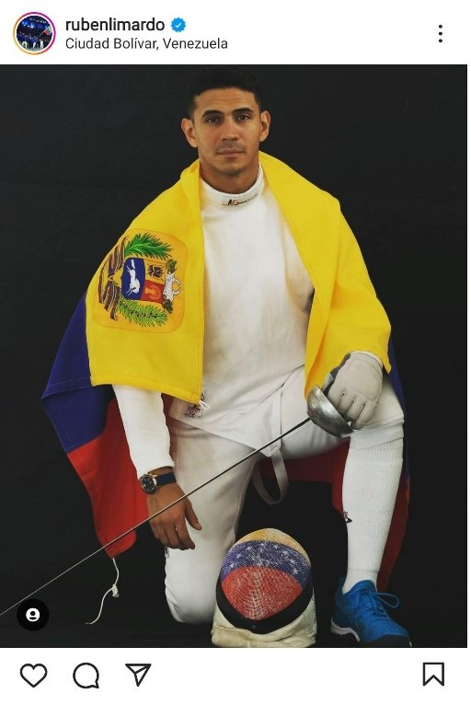
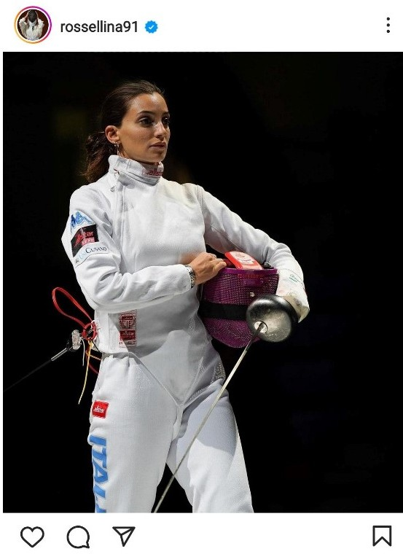

Note: Fencers M3 (left) and F5 (right) showing their professional activity Source: Instagram/Screenshot
The two other categories, volunteerism and brand endorsements (Figure 2), are relatively low on the list of posts by the athletes evaluat- ed, but they can still have a positive impact on the performance of fencing as a sport, although in some cases (e.g. paid advertising) they fall outside the ‘athletic performance’ dimension of the MABI (Arai et al., 2013). By participating in these activities, professional fencers can spread the message of fencing to a wider au- dience and increase the visibility of fencing to the public. Some examples of what they por- tray when they post about themselves include educational work in schools related to fencing (for volunteering) and promoting specific prod- ucts, such as dietary foods, to their audiences (endorsements and advertisements).
Endorsement activities, especially those that include paid partnerships with companies, can provide more financial support and resources to promote the marketability and commercial- ization of fencing. Furthermore, by participat- ing in voluntary work professional fencers can create a positive image and reinforce a sense of social responsibility and mission, which con- sequently helps to enhance the social image of fencing. However, these two activities are not necessarily an exclusive practice from fencers, as other athletes have historically dedicated themselves to both engaging in social work also using their personal brand to sell products.

MOST POPULAR FENCERS’ CONTENT AND ACTIVITY
After analyzing the content of the top fencers, we focused on the two most popular fencers on Instagram, F5 and F6, to better understand their sharing practices and interaction with fol- lowers. For the frequency of interaction, we cal- culated the average interactions (average num- ber of likes + average number of comments on all posts) of the two fencers with the highest number of followers on the platform (Table 4).
Table 4
Average interaction
A closer look at the content shows that dif- ferent types of posts receive different levels of interaction on average. For example, when comparing Training & Competition (T/C), Daily Life (DL), Charity & Volunteering (C/VC) and Ath- lete Branding & Endorsement (A/E), we noted that T/C and DL were the most popular types of posts. Hence, visual content depicting their professionalism and everyday life obtained more attention from followers. For example, humorous content, and photos with other ce- lebrities or athletes attracted more likes, thus increasing the average number of interactions on their posts.

Note: Most popular fencers’ average interaction on Instagram
Figura 5
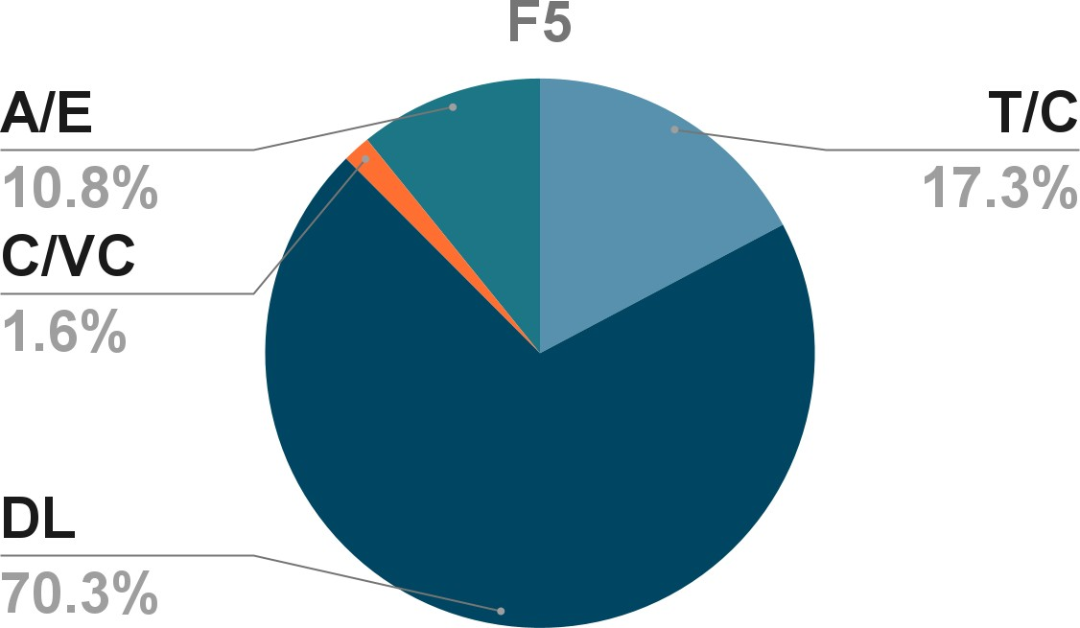
Tipo de publicación por esgrimistas
Ath- lete | Followers | AVG LIKES | AVG COM- MENTS | AVG INTER- ACTIONS
F5 | 300000 | 8946.31 | 58.81 | 9005.12
F6 | 207000 | 8439.06 | 68.94 | 8508

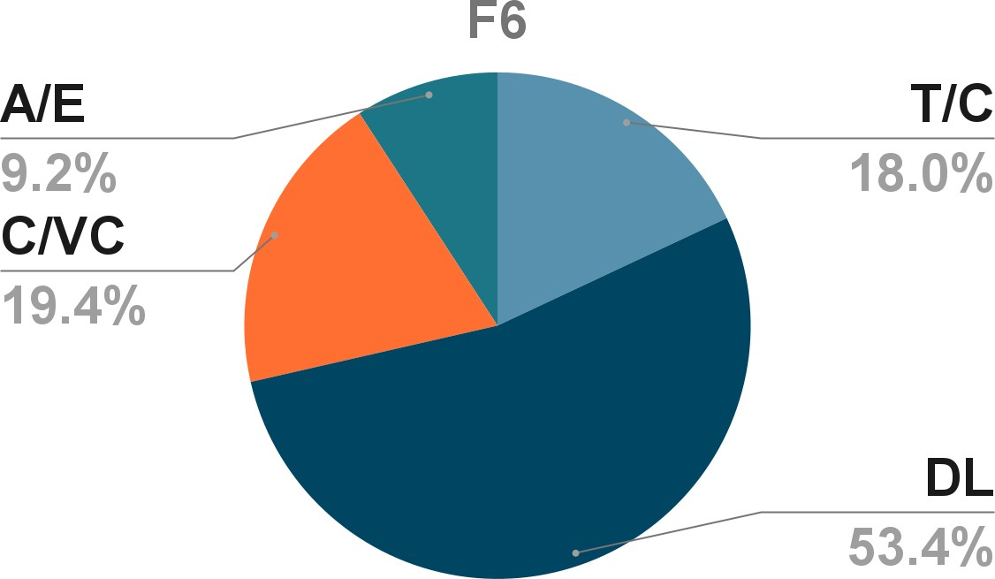

By looking at the data on professional fencers’ F5 and F6 post types (Figure 5), we found that they post mainly about their daily lives (70.3% and 53.4%, respectively), with training and competition appearing in second place for F5 (17.3%) and third place for F6 (18%). They share their daily life outside the training ground, fami-
ly gatherings, travel, healthy lifestyle during rest and recovery, interactions with coaches and teammates, etc. This content allows followers to gain a better understanding of the athletes’ lives and build a closer connection with them.

Figura 6
Actividad voluntaria y benéfica de la esgrimista M6
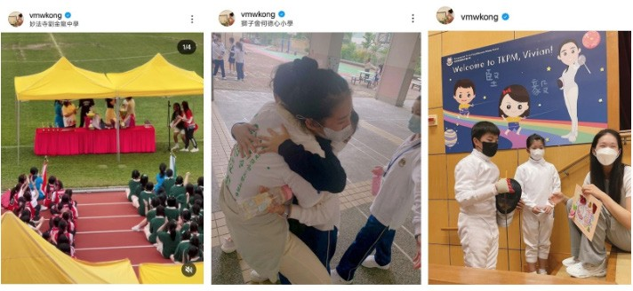
Note: Fencer F6 volunteer and charity activity content on Instagram

A clear distinction between the two most pop- ular professional fencers on Instagram refers to F6’s volunteer and charity activity (Figure 5), which reached second place (19.4%), even more than their training events. A large pro- portion of these volunteer and charity posts are about participating in or organizing fencing competitions for children and young people, or attending fencing courses in public schools (see Figure 6), which to an extent connects with their professional practice.

DISCUSSION AND CONCLUSION
The fact that visual social media, such as Ins- tagram, have become a relevant tool for ath- letes branding demonstrates the relevance of contemporary sport communication, which is still an evolving area of research. Centered on photo and video sharing, Instagram provides a global platform for sportspeople to connect with others, share their training and competi- tion events, and also depict their private lives. This allows athletes to be more actively involved in their public speaking and self-presentation (Lebel & Danylchuk, 2012; Sanderson, 2008), influencing the development of the communi- cation process.

Professional fencers use Instagram to inter- act with fans and viewers, share moments and behind-the-scenes footage of events, and promote their brand values, simultaneously incorporating into their online communication multiple dimensions of the MABI concept (Arai et al., 2013). This is important for sport commu- nication and promotion, as it allows athletes to engage more directly with their audiences.
This paper examines how professional fencers use Instagram to communicate about sports and finds that their active use of social media has multiple nuances and possible implications. In response to our RQ1 “What are the sport com- munication trends regarding professional fenc- ers’ self-presentation on Instagram?”, the study shows some directions in the athletes’ self-rep- resentation. For example, the number of posts and followers seem to be slightly correlated, suggesting that these users adopt the platform to actively showcase their fencing skills and per- sonalities in order to attract more viewers. The findings also suggest that fencers’ content fo- cuses more on the dimensions of ‘attractive ap- pearance’ and ‘marketable lifestyle’ than direct- ly on ‘athletic performance’, although this was also part of their self-presentation strategies. Hence, they look for ways to showcase their life beyond the piste, giving a face and a story to the competitor behind the fencing equipment, which contrasts with the practice observed by Lobillo Mora and Aja Gil’s (2020) in their discov- ery of pilot Jorge Lorenzo’s Instagram content.
In regards to our second research question, “How does the Instagram content of profes- sional fencers affect the perception of fencing as a sport?” The exploratory qualitative re- search shows that professional fencers’ online content may result in a positive impact on the image of fencing as a sport. By posting photos and videos of their practices and competitions, they promote their skills and competitive stand-
ing, attracting the attention of Instagram users. Moreover, this practice increases the gener- al public’s knowledge of the sport, making its characteristics more palatable through diverse visual elements (photos, videos, etc.). In addi- tion, by sharing content about their behind-the- scenes footage, and social involvement in char- ity work, brand endorsements favor the reach of fencing-related messages to new audiences that may be interested in these topics and, as a result, learn about the sport.
Finally, this research has identified trends, chal- lenges, and opportunities in sport communi- cation for the self-presentation of profession- al fencers on Instagram. They raise the profile and performance of fencing as a sport through diverse content and interaction with their au- dience. The presence of athletes on the plat- form is an important contribution to the sport communication market on a general level and to the modality in particular. By actively engag- ing and posting engaging content, they are able to attract more followers and viewers to them- selves, increasing the visibility of the individual and the sport.

LIMITATIONS AND FURTHER RESEARCH
This study aims to explore the contribution of professional fencers’ self-presentation on Ins- tagram as a sport communication strategy, with a focus on personal branding. Hence, it is im- portant to note that it only covers content on one platform and, therefore, does not provide representative data of fencers’ performance on all social media. To gain a more comprehensive understanding of an athlete’s self-presentation and impact on social media, future research could allow for cross-platform comparisons. Moreover, we conducted qualitative explorato- ry research based on visuals only, and other re- searchers could further evaluate the topic from

a quantitative perspective or on text-centered platforms.
Since the number of current studies on fenc- ers’ online self-presentation remains low and no established theoretical framework has been established, this paper provides a tentative ap- proach that offers support for research in this
area. Therefore, future analysis and exploration could be undertaken by other researchers to reveal the wider impact and strategies adopted by fencers on social media, thereby enhancing the understanding of their online branding.

REFERENCES
Abeza, G., O’riley, N., & Nadeau, J. (2014). Sport communication: A Multidimen- sional Assessment Of The Field’s Development. International Journal
Of Sport Communication, 7(3), 289–316. DOI: https://doi.org/10.1123/ IJSC.2014-0034
Agrippa C. (1604). Trattato Di Scienza D’arme. Et Un Dialogo In Dettamateria.
Venice, 1604.
Allen, B., & Reser, D. (1990). Content Analysis In Library And Information Sci-
ence Research. Library & Information Science Research, 12(3), 251-260. https://eric.ed.gov/?id=EJ421718.
Arai, A., Ko, Y. J., & Kaplanidou, K. (2014). Athlete Brand Image: Scale Devel-
opment And Model Test. European Sport Management Quarterly, 13(4), 383–403. DOI: Https://Doi.Org/10.1080/16184742.2013.811609
Arai, A., Ko, Y. J., & Ross, S. (2014). Branding Athletes: Exploration And Con-
ceptualization Of Athlete Brand Image. Sport Management Review, 17(2), 97–106. DOI: Https://Doi.Org/10.1016/J.Smr.2013.04.003
Arruda, W. & Dixson, K. (2007). Career Distinction: Stand Out By Building Your Brand, John Wiley & Sons.
Mogaji, E., Badejo, F.A., Charles, S. & Millisits, J. (2020). To Build My Career Or Build My Brand? Exploring The Prospects, Challenges And Opportuni-
ties For Sportswomen As Human Brand, European Sport Management Quarterly, 22(3), pp. 379-397. DOI: Https://Doi.Org/10.1080/16184742
.2020.1791209.
Benavides, C., Brito, J. I., Guerrero, J. I., & Tagle, F. (2021). Social perceptions
of the Chilean National Soccer Team as a brand. Obra Digital, N. 20, pp. 29-48. DOI: https://doi.org/10.25029/od.2021.0.20
Bernstein, A. & Blain, N. (2002). Sport and the media: the emergence of a ma-
jor research field, Sport, Media, Culture, Vol. 5(3), pp.1–30. DOI: https:// doi.org/10.1080/911094213

Billings, A. C. (2016). Defining Sport Communication (1st Edition). Routledge.

Kemp, S. (2023). Digital 2023. We Are Social Report. https://wearesocial.com/ uk/blog/2023/01/digital-2023/
Eagleman, A.N. (2013). Acceptance, Motivations, And Usage Of Social Media As A Marketing Communications Tool Amongst Employees Of Sport
National Governing Bodies, Sport Management Review, 16(4), Pp. 488- 497. DOI: https://doi.org/10.1016/j.smr.2013.03.004
Espinosa, R. S. C. (2021). Social media in communication: a constant topic of
discussion. Obra Digital, N. 20, pp. 10-13. DOI: https://doi.org/10.25029/ od.2021.0.20
Geurin-Eagleman, A.N., & Burch, M. B. (2016). Communicating Via Photo- graphs: A Gendered Analysis Of Olympic Athletes’ Visual Self-Pres-
entation On Instagram, Sport Management Review, 19 (2), pp. 133-145. Https://Doi.Org/10.1016/J.Smr.2015.03.002.
Hsieh, H.-F., & Shannon, S.E. (2005). Three Approaches To Qualitative Con-
tent Analysis. Qualitative Health Research, 15(9), pp. 1277-1288. DOI: https://doi.org/10.1177/1049732305276687
Hutchins, B. (2011). The Acceleration Of Media Sport Culture. Information,
Communication, & Society, 14, pp. 237–257. DOI: https://doi.org/10.108 0/1369118X.2010.508534
Kaplan, A.M. & Haenlein, M. (2010). Users Of The World, Unite! The Challeng-
es And Opportunities Of Social Media, Business Horizons, 53(1), pp. 59- 68. DOI: https://doi.org/10.1016/j.bushor.2009.09.003
Kim, A. J., & Hull, K. (2017). How Fans Are Engaging With Baseball Teams Demonstrating Multiple Objectives On Instagram. Sport, Business And
Management: An International Journal, 7(2), pp. 216–232. DOI: https:// doi.org/10.1108/sbm-01-2017-0002
Kozinets, R. V. (2010). Netnography. Doing Ethnographic Research Online. Sage Publications.
Krippendorff, K. (2018). Content Analysis: An Introduction to Its Methodology.
Sage Publications.
Kutzer, M. (2016). Professional Athletes Role In Society Via Social Media. Loy- ola University of Maryland. https://www.loyola.edu/academics/emerg- ing-media/blog/2016/professional-athletes-social-media
Labat, J.D. (1696). L’art en fait d’armes. Imprimeur J.Boude, Toulouse, 1696. Lebel, K., & Danylchuk, K. (2012). How Tweet It Is: A Gendered Analysis Of
Professional Tennis Players’ Self-Presentation On Twitter. Interna-
tional Journal Of Sport Communication, 5, 461–480. DOI: https://doi. org/10.1123/ijsc.5.4.461

Lobillo Mora, G. M. y Aja Gil, M. (2020). Estudio de la presencia digital en MotoGP: Estudio de caso Jorge Lorenzo en Instagram. Ámbitos. Re- vista Internacional de Comunicación, 48, 102–122. DOI: https://doi. org/10.12795/Ambitos.2020.i48.06
Lobpries, J., Bennett, G., & Brison, N. (2018). How I Perform Is Not Enough: Ex- ploring Branding Barriers Faced By Elite Female Athletes. Sport Marketing Quarterly, 27, 5-17. DOI: https://doi.org/10.32731/smq.271.032018.01
Ma, H. (2021). Youth Reference. Young Gen. http://qnck.cyol.com/html/2021- 09/03/nw.D110000qnck_20210903_1-06.htm
Manikonda, L., Hu, Y., & Kambhampati, S. (2014). Analyzing User Activities, Demographics, Social Network Structure, and User-Generated Con- tent on Instagram. ArXiv, abs/1410.8099.
Marion, E. & Hambrick, M. E. (2017). Sport communication research: A social
network analysis. Sport Management Review, 20 (2), pp. 170-183. DOI: https://doi.org/10.1016/j.smr.2016.08.002.
Meraz, S. (2009). Is There An Elite Hold? Traditional Media To Social Media Agenda Setting Influence In Blog Networks. Journal Of Computer-Medi-
ated Communication, 14, 682–707. DOI: https://doi.org/10.1111/j.1083- 6101.2009.01458.x
Mogaji, E., Bádéjọ, F.A., Charles, S., & Millisits, J. (2020). To build my career or build my brand? Exploring the prospects, challenges, and opportuni- ties for sportswomen as a human brand. European Sport Management
Quarterly, 22, 379 - 397. DOI: https://doi.org/10.1080/16184742.2020
.1791209
Na, S., Kunkel, T. & Doyle, J. (2020). Exploring athlete brand image develop- ment on social media: the role of signalling through source credibility.
European Sport Management Quarterly, 20(1), pp. 88-108. DOI: https:// doi.org/10.1080/16184742.2019.1662465
Parmentier, M. A., & Fischer, E. (2012). How Athletes Build Their Brands. Inter-
national Journal Of Sport Management And Marketing, 11(1-2), 106–124. DOI: Https://Doi.Org/10.1504/Ijsmm.2012.045491
Pedersen, P. M.; Laucella, P. C.; Miloch, K.S.; & Fielding, L. W. (2007). The juxta- position of sport and communication: defining the field of sport com-
munication. International Journal Of Sport Management And Marketing,
2(3), pp 193-207. DOI: Https://Doi.Org/10.1504/IJSMM.2007.012400.
Poletti, A. (2011). Coaxing An Intimate Public: Life Narrative In Digital Storytell-
ing. Journal Of Media & Cultural Studies, 25(1), pp. 73–83. DOI: https://doi. org/10.1080/10304312.2010.506672
Porzio L. & Mele, G. Arte Gladiatoria Dimicandi. 15th Century Swordsmanship Of Master Filippo Vadi. Chivalry Bookshelf.

Roi, G. S. & Bianchedi, D. (2008). The Science Of Fencing. Sports Med, 38, pp. 465–481. DOI: Https://Doi.Org/10.2165/00007256-200838060-00003
Romney, M. & Johnson, R. G. (2020). Show Me A Story: Narrative, Image, And Audience Engagement On Sports Network Instagram Accounts. Infor-
mation, Communication & Society, 23(1), pp. 94-109. DOI: Https://Doi.Or g/10.1080/1369118x.2018.1486868.
Romney, M., & Johnson, R. G. (2020). The Ball Game Is For The Boys: The Visual Framing Of Female Athletes On National Sports Networks’ Insta-
gram Accounts. Communication & Sport, 8(6), pp. 738–756. DOI: Https:// Doi.Org/10.1177/2167479519836731
Sanderson, J. (2008). The Blog Is Serving Its Purpose: Self-Presentation Strategies On 38pitches. Com. Journal Of Computer-Mediated Com-
munication, 13, pp. 912–936. DOI: https://doi.org/10.1111/j.1083- 6101.2008.00424.x
Sanderson, J., & Kassing, J. W. (2011). Tweets And Blogs: Transformative, Adversarial, And Integrative Developments In Sports Media. In A. C.
Billings (Ed.), Sports Media: Transformation, Integration, Consumption (pp. 114–127). Routledge
Serafinelli, E.; Villi, M. (2017). Mobile Mediated Visualities: An Empirical Study of Visual Practices on Instagram. Digital Culture & Society. Mobile Dig-
ital Practices, 3(2), pp. 165-182. DOI: https://doi.org/10.25969/medi- arep/13520.
Smith, L. R.; & Sanderson, J. (2015). I’m Going To Instagram It! An Analysis Of Athlete Self-Presentation On Instagram. Journal Of Broadcasting & Elec-
tronic Media, 59(2), pp. 342-358. DOI: https://doi.org/10.1080/088381 51.2015.1029125.
Toivonen, S. (2007). Web On The Move. Landscapes Of Mobile Social Me-
dia. Vtt Research Notes, 2403, Espoo. DOI: https://www.vttresearch.com/ sites/default/files/pdf/tiedotteet/2007/T2403.pdf

Veloso, A. S. (2018) Geração Digital e a Mediação Da Experiência De Visibilidade: estudo sobre Stories em aplicativos e redes sociais nos dispositivos móveis
entre adolescentes. [Digital Generation and the Mediation of the Expe- rience of Visibility: a study on Stories in apps and social networks on mobile devices among adolescents.] Belo Horizonte: PUC Minas, 2018.
Veloso, A. S. (2021). Visual communication in the age of digital-networked im- ages: an analysis of Instagram Stories features. In INMECS21, 1. Uluslar- arası Medya ve Kültürel Çalışmalar Konferansı, Dijital Dünyada İletişim,
Sanat ve Kültür, 6-7 Eylül 2021, Hasan Kalyoncu University, Gaziantep, Turkey, pp. 264-275.
Walsh, P., & Williams, A. (2017). To Extend Or Not Extend A Human Brand: An Analysis Of Perceived Fit And Attitudes Toward Athlete Brand Ex-
tensions. Journal Of Sport Management, 31(1), 44–60. DOI: Https://Doi. Org/10.1123/Jsm.2015-0314

