Fake News: propagation and communities, how are they related?
Fake News: propagación y comunidades, ¿Cuál es su relación?
9
ARTICLE

Cristiano Max Pereira Pinheiro
Universidade Feevale y Laboratório de Criatividade

PhD in Social Communication, MSc in Social communication and BA in Advertising. Former coordinator of the Journalism, Public Relations and Advertising programs and currently professor and coordinator of FEEVALE University’s Creative Industry Master’s and Doctorate programs. Currently coordinates the research project: `The content creation process in Creative Sectors’ and the Creativity Laboratory.
maxrs@feevale.br
ORCID: https://orcid.org/0000-0002-2038-8191

Thiago Godolphim Mendes
Universidade Feevale y Laboratório de Criatividade

MSc in Design and Technology from UFRGS. BA in Advertising from PUCRS. Currently a professor at FEEVALE University, where he teaches in the Creative Industries courses. Coordinated the Audiovisual Production and Advertising courses at the same university and participates as researcher in FEEVALE University’s Creativity Laboratory.

thiago.god.mendes@gmail.com
ORCID: https://orcid.org/0000-0003-4057-7907

Eva Caroline da Silva Ev
Universidade Feevale y Laboratório de Criatividade

BA in Advertising from FEEVALE University and winner of awards such as Best Advertising Campaign - Mentes Brilhantes (2020), Best Transmedia Project - Mentes Brilhantes (2020), Best Campaign - Madrugadão PRO (2019) and Best Audiovisual production for Video Clip - Mente Brilhantes (2019).

evacarolinesilva@hotmail.com
ORCID: https://orcid.org/0000-0003-3302-102X

OBRA DIGITAL 24, December 2023, pp. 167-183, e-ISSN 2014-5039 DOI: 10.25029/od.2023.383.24

167

Eva Fabbiana Bez Galarza
Universidade Feevale y Laboratório de Criatividade

Undergraduate in Biology from FEEVALE University. Scientific scholarship holder for Cluster GameRS in the Rio Grande do Sul state. Participates in the development of the TKE Corporative University project, was part of the Creativity, Teaching and Minecraft project. Currently a member of the FEEVALE University’s Creativity Laboratory.

evabezg@gmail.com
ORCID: https://orcid.org/0000-0001-5729-5434

Thomás Czrnhak
Universidade Feevale y Laboratório de Criatividade

BA in Fashion from FEEVALE University. FAPERGS PDTI level 5 scholarship holder, manager of the GameRS Cluster, PIBITI former scientific scholarship holder, editor and researcher of PREVERS - Behavioral Trends Research - and member of the FEEVALE University’s Creativity Laboratory.

0285616@feevale.br
ORCID: https://orcid.org/0000-0002-0814-1233 RECEIVED: 2023-05-12 / ACCEPTED: 2023-07-19

Abstract:
The present study investigates the growing role of fake news in digital communities and the po- tential impact resulting from its rapid spread. To achieve this, netnographic methodology was utilized along with lurking observation, the latter to preserve the integrity of participants. Data collection focused on two politically sim- ilar groups with open access on WhatsApp, whose data provided a deep understanding of fake news and its influence on decision-making, as well as possible reasons for its easy and rap- id spread through the internet.
Keywords: fake news, digital communities, impact, netnographic methodology, lurking
observation, social communication.

Resumen:
El presente estudio investiga el creciente papel de las fake news en las comunidades digitales y el posible impacto resultado de su rápida propagación. Para ello, se usó la metodología netnográfica, junto con la observación lurking. Esta última se usó para preservar la integridad de los participantes. La recopilación de datos se enfocó en dos grupos políticos de ideologías similares con libre acceso en WhatsApp. Dichos datos permitieron una comprensión más deta- llada sobre la influencia de las fake news en la toma de decisiones, además de las posibles razones de su fácil y rápida propagación por internet.
Palabras clave: fake news, comunidades digi- tales, impacto, metodología netnográfica, ob-
servación lurking, comunicación social.

- INTRODUCTION
In 2017, the term fake news was the most searched word in browsers. This creates a new insight into their remarkable growth; they are up to 70% faster to disseminate than real news (Vosoughi et al., 2018).
Brazil is one of the countries where such fake news is highly accepted and widespread. It is estimated that 9 out of 10 people have already received at least one fake news story through a social network and that more than half of these users have contributed to its dissemination.
In 2018, Brazil was going through a period of presidential elections. In this year, according to reports presented by the cybercrime laborato- ry PSafe (2018), there was a significant increase in the dissemination of fake news. Social net- works (mainly Facebook and WhatsApp) were the main tools used to achieve the reach ob- served in this type of news.
To understand the spread of fake news by users and the role of social capital in the exchange of information, the social network WhatsApp was chosen as the main source for collecting data.

POST-TRUTH ERA: CURRENT AFFAIRS AND CONCEPTS
Post-truth and fake news stem from the fluid communication conditions in the globalized world and how these conditions have disrupt- ed the concepts of what is true and what is a lie (Waisbord, 2018). Borges Junior (2019) defines post-truth as a clash between a) objective and variable facts and b) individual emotions in the form of beliefs.
According to Nietzsche (1873), the truth never mattered; people in earlier centuries feared the act of lying and internalized it in the form
of shame or kept it a secret. Nowadays, on the contrary, lies have gained a very important role in society, since they are mainly used to influ- ence others through factors such as persuasion of an idea. Some justification is sought to trans- form them into something true (Keyes, 2004). This is a behavior that, according to Nietzsche (1873), would amount to dissimulation, a char- acteristic very representative of the post-truth era (Keyes, 2004).
Within the existentialist current, authors such as Nietzsche (1873) and Kierkegaard (1968) conceptualize truth as a construction of the hu- man intellect, indispensable for shaping a sense of morality and ethics in society, which can be represented almost entirely through communi- cation. Nevertheless, some individuals prefer to escape from any feature that represents truth to live their reality.
The formation of different identities, each with its unique perspective on the world, can divide society and lead to the creation of simulated groups (Deleuze, 2006). These groups can be very accurate representations of reality, even though they exist in a fictional context. This pro- cess of exclusion from the world around them can give the impression that their reality is the only true one (Baudrillard, 1991).
Post-truth as an abstract concept is propor- tional to a simulacrum that arguably has always existed. This is based on the ideas of Keyes (2004) and Nietzsche (1873). They suggest that the manipulation of information and creation of imaginary scenarios are not new develop- ments, but rather have been around for some time. This idea is further strengthened by ad- vancements in technology and communication, which have enabled individuals to engage with the online community.

FAKE NEWS
In more recent literature, fake news has been the subject of constant discussion and is com- monly associated with post-truth (Waisbord, 2018; Borges Junior, 2019) and with political and partisan processes (Bakir & McStay, 2018; Pennycook & Rand, 2018; Tandoc et al., 2018). However, authors such as Zhou and Zafara- ni (2020) reject that the phenomenon of fake news poses a threat to democratic society.
Fake news is information manipulated to be shared on social networks (Pennycook & Rand, 2018). They have a structure mainly focused on attracting the attention of individuals, which generates, almost always in an accidental way, a diffusion of the same (Netto & Peruyera, 2018).
According to these authors, fake news is seen as a current expression to name old practices of manufacturing news without verifying reality. They have an obvious objective: to deceive the reader (Netto & Peruyera, 2018). This purpose can be seen in the credibility, visibility, and ve- racity that media communication can give to content (Bakir & McStay, 2018).
Fake news generated directly by journalists or related media is only one of the theories. The other possible source of fake news is related to user-generated content (UGC) in the form of user-related theories. In these spaces, us- ers post, share, like, and comment on their like-minded ideas (Zhou & Zafarani, 2020).
Scholars believe that the term fake news is cur- rently being misused and has been reduced almost entirely to aggressions and defama- tions towards other people. As a result, it has become a much more serious problem (Netto & Peruyera, 2018).
In this regard, Genesini (2018) believes that: just as fake news has always existed, so have
interactions and changes between individuals defending their beliefs and interests. This could change the fact that nowadays the influence of online platforms has radically changed the dissemination and creation of information that, for very different reasons and almost always without explanation, goes viral and increases its audience from one moment to the next in an exorbitant way.
The literature on fake news has revealed con- cerns about the dissemination methods of fake news. Fake news has content that is usually more eye-catching and easier to understand than authentic news. It manages to stimulate certain senses in the reader (hearing, sight and even touch) to achieve its goal, which is to de- ceive the reader (Alves, 2018; Genesini, 2018; Netto & Peruyera, 2018).
Contrary to some literature findings, Penny- cook and Rand (2018) argue that believing disinformation or lies is not linked to political bias, but rather to a lack of critical thinking. The authors argue that the internet has overtaken this and agree that, although fake news has been around for a long time, its spreading has become more alarming and rapid due to mass access to the internet.
Within the realm of internet disinformation, fake news is just one category, alongside ru- mors and clickbait (the use of sensationalist messages to attract attention), and social spam (unwanted promotional content) (Bondielli & Marcelloni, 2019).
Wardle (2017) lists the possible categories of fake news as follows: a) mockery or parody; b) misleading content; c) fraudulent content; d) fabricated content; e) false connection; f) false background; g) manipulated content. This can be seen depicted in Figure 1.

Figure 1
Categorical display of the types of fake news
Within fake news, credibility is considered one of the most important characteristics (Quirós, 2017). This can be acquired through factors such as the speed of information sharing. This element can be both essential for the construc- tion of an identity and the acquisition of values in simulacra and a determinant for truth to be of much lesser importance. Thus, truth be- comes less relevant (Alves, 2018).
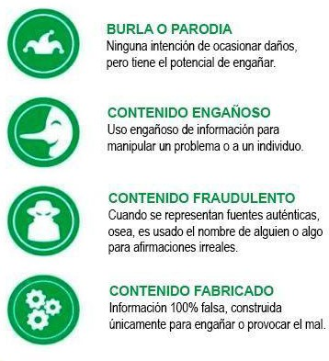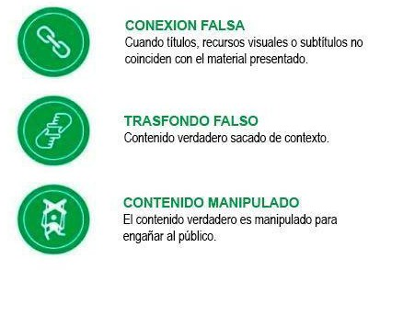Following this line, Bondielli and Marcelloni (2019) offer a classification of other types of dis- information on the internet, including mocking and humorous content, manipulated content, or rumors, as represented by Wardle (2017). To these, we can add those depicted in Figure 2 as other extensions of disinformation.

Note: Image created by the authors based on Fake News. It’s complicated, by Wardle, 2017.

Figure 2
Categories of disinformation on the web.
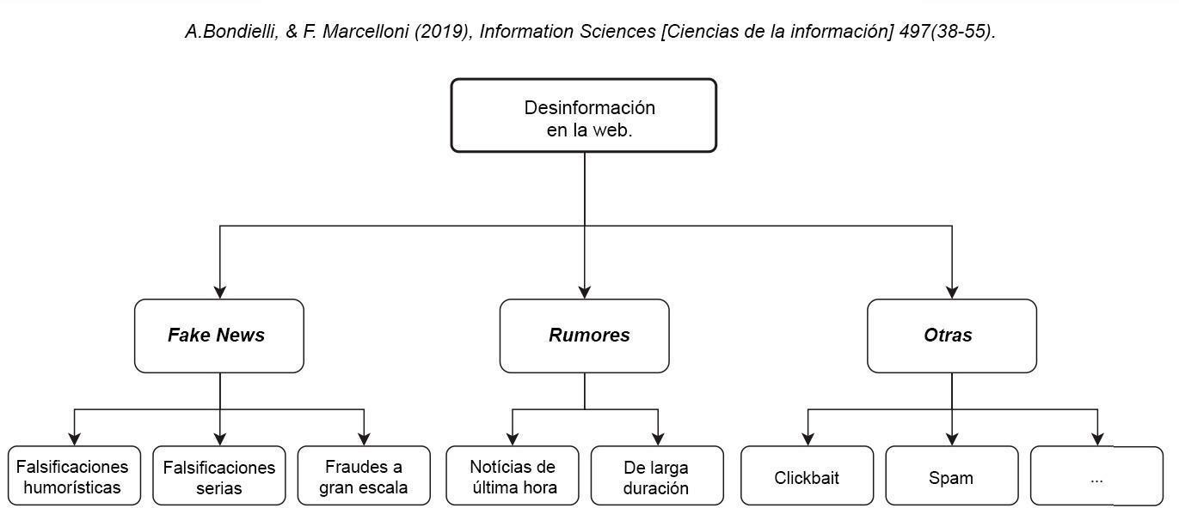
Note: Authors’ translation. Adapted from A survey on fake news and rumor detection techniques (p. 41), by A. Bondielli and F. Marcelloni, 2019, Information Sciences, 497.

Another phenomenon is deepfakes, which are highly realistic audiovisual material that manip- ulates the image of a figure to make them ap- pear to be saying something they have not said. However, it poses some risks regarding altered speeches of public figures, which can potential- ly interfere with elections and the security of users (Westerlund, 2019).
Fake news has found itself in the post-truth era with a landscape of segregation, where what is different is ignored and belittled (Deleuze, 2006). With very diverse origins (Alves, 2018), fake news can be liked or disliked by the public; due to the wide range of interactions they can generate, they usually make this process fast and uncontrolled (Genesini, 2018). This allows algorithms to better understand people’s pref- erences and facilitates the development of digi- tal simulations and connections between users through algorithms.
Westerlund (2019) argues that the most wide- ly adopted avenues in the literature to combat the spread of fake news are state regulation, private governance, and voluntary action. How- ever, it is important to note that given the scale
and prevalence of fake news, it is unlikely that the phenomenon can be eliminated, although it is likely to be drastically reduced (Bakir & Mc- Stay, 2018). One of the main reasons for this problem is that fake news is usually the product of virtual communities (Zhou & Zafarani, 2020); therefore, these are communities made up of individuals whose behaviors that generate fake news cannot be fully controlled.

ONLINE COMMUNITIES
Before the popularization of technology that enabled new forms of social relations, a com- munity was understood as an association of people with high social interactions based on common interests and values acquired from everyday conceived relationships. However, they depended on the same territorial location and consisted of small groups.
With the advent of communication and infor- mation technology, this term may have had some variations, specifically in the character- istics that delimit communities to a particular

place. This has, as a consequence, the begin- nings of deterritorialization (Thompson, 2001).
Virtual communities are online (digital) spaces where interpersonal exchanges and relation- ships take place. Thus, an environment for the generation of social value in the form of capital emerges (Faucher, 2018).
For Agostini and Mechant (2019), such commu- nities are seen as a grouping of individuals or companies that promote social relations with a common interest. Within this space, interac- tions are conducted through a common lan- guage and a set of agreed protocols.
As Rodrigues (2023) notes, the absence of bar- riers to entry to the Internet opened the door to creating inclusive connections. According to Putnam (2000), this occurred in several ways:
    - bridging (weaker but more diverse connec- tions and ties, in the form of dissemination of information and data); or b) bonding (exclusive, with stronger and more intimate ties, more homogeneous in terms of group opinions due to the high degree of shared experiences and identities). The system operates on the logic that weaker ties allow for more diverse rela- tionships with other individuals (Mishra, 2020).
Samuel (2018) points to the social network WhatsApp as a tool that revolves around these connections. These connections are good for sharing interests, keeping in touch with others, and engaging in discussions and debates.
Peck (1987) describes eight categories for the design and development of communities and the involvement of their members: (i) inclusion, compromise and agreement; (ii) realism (a plu- rality of views); (iii) deliberation (decisions are made unanimously and collectively); (iv) a safe place (trust); (v) a social deconstruction labora- tory (a socially supportive environment prone to exploring new forms of behavior); (vi) a group
capable of ‘fighting back’ (support in conflict resolution); (vii) a group of leaders (all are lead- ers in decision making); (viii) a spirit (a sense of belonging to a community or group).
The metamorphosis of space and place brought about by the advent of technology has led to a debate about the true meaning of space on the internet. Tools such as WhatsApp can bring communities together and give the concept of space a completely different meaning (Samuel, 2018).
McLuhan (1964) suggests a link between this process of deterritorialization and the emer- gence of alternative means of transport and communication. According to the author, this technological development has made it pos- sible for people to communicate with great- er ease and almost everywhere. The original meaning of community is thus restored.
All these changes are thought to be responsi- ble for the emergence of the new term virtual communities. Rheingold (1993) refers to them as social aggregations created by a specific group of people who manage to form person- al relationships in cyberspace. This is because they hold public discussions with human senti- ments at a given time.
To complement this idea, Baudrillard (1991) asserted that the emergence of new technol- ogies, virtual communities, and cyberspace would result in the disappearance of a sense of reality or participation in society.
On the contrary, Lemos (2002) refers to this type of community as groups that form around shared interests, regardless of borders or spe- cific territorial limits. Following this line, Agostini and Mechant (2019) affirm that virtual commu- nities begin in an a priori way, from an imagi- nary process in which individuals project them-

selves in an immaterial way as a grouping of individuals.
There are also great thinkers, such as Primo (2000), Wellman and Gulia (2000), who defend the idea that cyberspace and the emergence of the Internet have been able to create environ- ments where society can develop in different ways, creating richer connections than commu- nities limited to one place.
These communities, stemming from technolog- ical advances, specifically in the fields of infor- mation and communication, made it possible to create new formats for the content found on these networks.
All this progress ended up shaping the crea- tion of its content, converging with traditional formats (Jenkins, 2008). The content created and shared (interactions) with and towards users represents a form of influence on deci- sion-making and the perception of trust (Terra, 2010).
The generation of content by users (UGC, pho- tos, videos and audio) is a key factor in the prop- agation of fake news, according to the theory of user-generated fake news (Zhou and Zafarani, 2020). In virtual communities, members play an active role as co-creators within the structures of WEB 2.0 (Maffie, 2020).
Although virtual communities do not have a physical space and do not depend on such strong ties, they still have some characteristics of unity. This makes it possible to classify them into three broad groups (Recuero, 2009).
Emerging communities are based on mutual social relations (Primo, 2000). They have an axis made up of users who are more closely con- nected through strong ties (intimacy, trust, and/ or emotion), and in their periphery, they have “nodes” that are either not developed and rout- ed to the axis or are disconnected from it.
On the other hand, association or affiliation communities are characterized by relatively low levels of interaction. Their most significant char- acteristic has to do with reactive social interac- tions (Primo, 2000), formed by clusters inter- nally linked by common interests. They are held together by their group affiliations, without the need for actual interactions (Recuero, 2012).
Hybrid communities have characteristics of the two communities mentioned above, the only difference being that within them there is an ‘actor’ and around them, emerging com- munities are formed, which may also be linked to different communities with some common interest. This makes the nodes interconnected in order to achieve an exchange of information between each of them (Recuero, 2012).

SOCIAL CAPITAL
The relationships between individuals that are present in the clusters of communities are part of a very specific type of capital: social capital. Faucher (2018) considers social capital as an asset resulting from social relationships and the maintenance of their connections from the following perspectives: a) as a product of online exchanges, which may or may not be linked to a specific network community; or b) in the case of a network owner or leader, the work of users can be used as data and then converted into profit.
Interaction between members of a network or a group is related to performance. To perform is to show someone something you know or think you know, which causes an influence on them due to a combination of action, socializa- tion, and/or observational behaviors (Schech- ner, 2003).
Based on the idea of virtual communities in- troduced by Agostini and Mechant (2019), re- search on social capital suggests that it has a

positive impact on network performance. This is mainly due to the exchange of knowledge and experiences, as outlined by Swan et al. (2020). How the forms and resources of social capital are used depends largely on the compo- sition and characteristics of the members of a network or community (Mishra, 2020).
Although social capital outcomes are often re- lated to economic outcomes, there are still in- teresting parallels with non-explicitly economic outcomes. For example, trust is an attribute closely linked to social capital (Rodrigues, 2023). Results indicate that, in an interconnect- ed network, cooperation and trust are related to group performance (Salume, Guimarães & Rantisi, 2019). This can also be used for com- munity relations.
Through the social capital that comes from the interactions between users, the relationship of trust, a network value, occurs (Terra, 2010). This is related to the viral content that arises, according to O’Connor (2008), from blind belief, appreciation, and trust.

METHODOLOGY
The process for conducting this research be- gan with a literature review of scientific articles published in journals. An attempt was made to select the most recent and relevant works on the topics studied (Thomas, 2021). In the case of this study, bibliographic materials on fake news and social capital were consulted.
To collect and analyze the data, the netno- graphic method was used, which is based on lurking observation (passive observation); that is, the researcher participates as a covert spectator in an online community to observe practices, interactions, and conversations. This facilitates entry into and engagement with the social group under study (O’Leary, 2021).
Netnography, for this context, corresponds to a traditional ethnographic extension, where re- searchers enter a digital and online community, going through the stages of immersion in that group, collection, reflection of observation, and communication of qualitative findings and phe- nomena (Kozinets, 2019).
To apply these methodologies, creating a per- son to facilitate access to the groups neutrally was necessary. He was given the name Ricardo (one of the most registered names in the 70s and 80s) dos Santos (one of the most common surnames in Brazil), and his profile picture was taken from a freely accessible image bank. A telephone chip was acquired exclusively for this investigation.
As proposed in the netnographic methodol- ogy, pseudonyms were used for each of the members of the communities. This was done to protect the privacy and integrity of each of the people involved (Maddox, 2021).
After integrating our fictitious person, man- aged by one of the authors, into the selected WhatsApp groups, data collection was initiated directly from the source to describe the social interactions generated by the different con- tent generated by users associated with these groups.

RESULTS
There were some difficulties in finding and ob- taining groups from which to extract the data needed for this research, particularly left-lean- ing groups. Nevertheless, it is strongly argued that working with groups with relatively similar ideologies and characteristics was one of the factors that led to a better understanding of the spread of fake news and its behavior within different groups and simulacra.

As this is a netnographic research, it is worth noting that many of the situations that are pre- sented below may have occurred during the period of observation of the communities but tend to be explained separately as they contain different characteristics but are relevant to the specific themes of the present study. The imag- es, originally in Portuguese, have been translat- ed into Spanish.

CHARACTERISTICS OF THE COMMUNITIES
The groups used for the research are available on internet sites and are searched by people with political interests, with the aim of increas- ing this type of knowledge. Thus, the character- istics mentioned by Lemos (2002), Rheingold (1993) and Agostini and Mechant (2019) to be called virtual communities are fulfilled.
In Figure 3, in the “IP - Closed Group” on 24 September 2019, a video was shared with ap- parently false information about a YouTuber named Felipe Neto. This was an attempt to jus- tify a discussion that had previously been raised in the group. However, it made other members feel uncomfortable and sparked a debate that generated opinions that did not agree on the veracity of the matter.
Figure 3
Conflict in IP - Closed Group

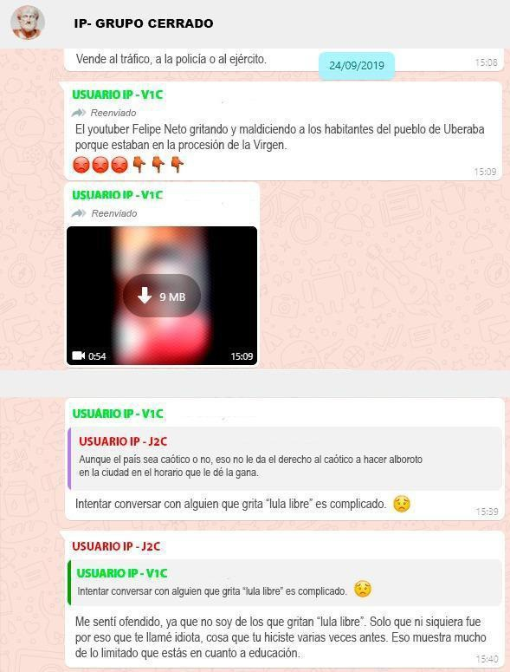
Note: Screenshot from WhatsApp, translation by the authors.

Figure 4 shows a discussion in “RP - Open Group”. In contrast with the “IP - Closed Group”, conflicts are largely influenced by the intensity of the ties among the participants. These ties can either be homogeneous and strong or weak and diverse (Mishra, 2020). In this case, the participants are more experienced users in the group, resulting in less rude discussions and generating less dissatisfaction among the other participants.

Figure 4
Conflict in RP - Open Group

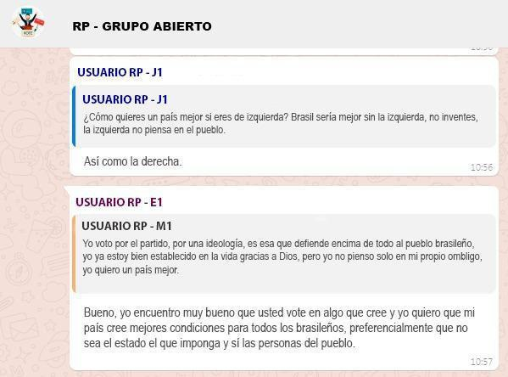
Note: Screenshot
from WhatsApp, translation by the authors.

Based on the mentioned factors, there are dif- ferences that can be discussed among these groups.
IP - Closed Group: Despite the similar ideals managed in it, the community formed seems to have fragile ties and is mainly used as a source of political information. Frequent aggressive de- bates among its users characterize this group, and no attempt is made to support each other; therefore, according to the parameters estab- lished by Recuero (2009), this group would be classified as a community of association or af- filiation.
RP - Open Group: With a better sense of what a community is, strong bonds can be found within this group. This is due to the diversity of ideals and opinions shared within it, and it is precisely this diversity of thought that makes it less complicated to neutralize unfounded de- bates and enforce or encourage compliance with the rules imposed within the communi- ty. Thanks to the values developed within this group and according to the parameters es- tablished by Recuero (2009), the community formed within this group could be classified as an emergent community.

SIMULATIONS
On 30 August 2019, a news item with unreli- able information was shared on IP – Closed Group, which allegedly showed comedian Gus- tavo Mendes offending his audience with rude words and attitudes, after being criticized for making fun of the then-President Jair Bolsona- ro. This generated comments from other com- munity members and violated the principles established within the community, as seen in Figure 5 below.
Figure 5
Conflict in IP – Closed Group

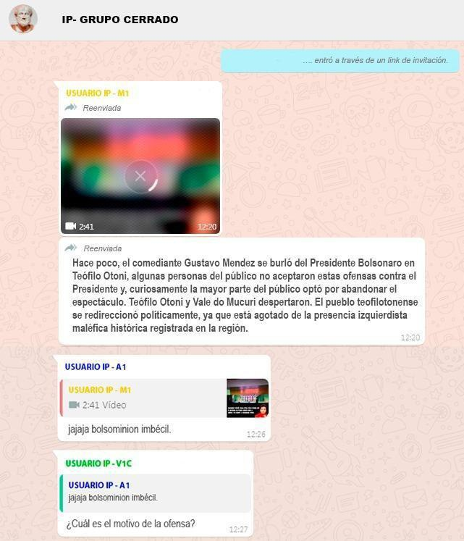
Note: Screenshot from WhatsApp, translation by the authors.

The situation presented above can be identi- fied as one of the many examples of simula- tion that took place within the IP-Closed Group, in which, following Nietzsche’s (1873) line of thought, members set aside their shared val- ues to concentrate on defending an opinion that they believe to be indisputably true. In do- ing so, they ignore any other idea that contra- dicts their own. The term bolsominion, used in a derogatory way by user IP - A1, refers to the voters and supporters of the then President of the Republic, Jair Bolsonaro.
Similar situations occurred in RP - Open Group. For example, Figure 6 shows a discussion trig- gered by a member’s comment that poor peo- ple cannot support right-wing ideologies.
Figure 6
Conflict in RP - Open Group.
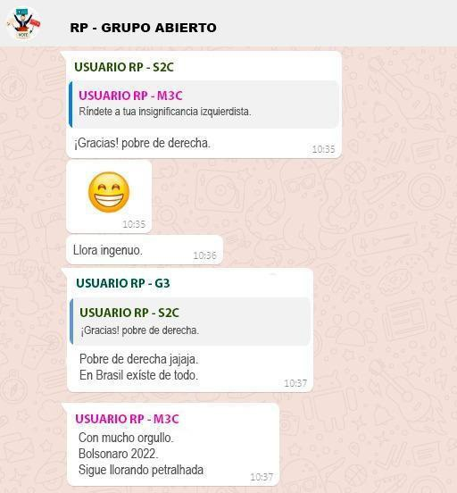
Note: Screenshot from WhatsApp, translation by the authors.
In the given scenario, certain members utilize their cultural backgrounds to spark discus- sions, not only to influence others but also for amusement and to generate debate around their arguments (Schechner, 2003). This re- sults in other members aligning themselves with those individuals. However, this also highlights the presence of distinct simulations that comprise the community (Deleuze, 2006; Baudrillard, 1991). The word petralhada is used in a derogatory manner to describe members or supporters of the Brazilian Partido dos Tra- balhadores (PT).
IP - Closed Group is seen as a community with simulacra that are not constrained by general resources and are much more effective at dis- mantling fake news. This means that fake news has little or no impact on discussions, so it is not possible to influence the users belonging to the group (Schechner, 2003). The environment has proven to be a fertile one for the promo- tion of beliefs without much consideration or fuss about critical thinking (Pennycook & Rand, 2018).
Within the IP-Closed Group, a higher recurrence of fake news could be identified. Following the ideas of Wardle (2017) and Bondielli and Mar- celloni (2019), these would belong to the group of misleading content with false context. These contents aim to ratify an ideological position in the community and generate debates that may favor the performance of users (Schech- ner, 2003) through easy connection processes (Genesini, 2018; Baudrillard, 1991).
This is why the interest placed by users is based on incorrect or unsubstantiated argumentation as a tool to obtain a particular type of reaffirma- tion or performance (Deleuze, 2006; Schech- ner, 2003). This makes the verification of news almost non-existent.

USERS WITH MORE POWER FOR DISSEMINATION
In the two groups in which the research was applied, it was possible to identify users who spread fake news. These users acted as ac- tive members who were exclusively dedicated to frequently sharing this type of content with unreliable sources (Terra, 2010). This was their only form of interaction with the other mem- bers of the groups (Jenkins, 2008).
In RP – Open Group, there was no evidence of inappropriate or disrespectful discussions due to fake information being shared. Usually, users tend to deny this type of fake news shared by the aforementioned users, as they send links or information with reliable sources (Terra, 2010). For all these reasons, despite the existence of users who spread fake news, it is not possible to guarantee that they have sufficient social capital to maintain them for a long time (Recue- ro, 2009).).
In the IP - Closed Group, as opposed to the RP - Open Group, these users dedicated to the dissemination of fake news usually have a much higher social capital (Recuero, 2009) due to the propagation force existing in this group. On most occasions, the sharing of this news results in the emergence of conversations that generally involve those responsible for sharing this information. This all depends on the type of relevance or interest that the shared content has generated (Terra, 2010; Genesini, 2018;
Genesini, 2018).
For its part, shared digital content is used by both communities as a tool for incorpora- tion (Peck, 1987), defense (Baudrillard, 1991; Deleuze, 2006), and as a factor in the construc- tion of individual values (Schechner, 2003; Ter-
ra, 2010). In this way, the RP - Open Group’s efforts to counter false information shared in the group can be effective in achieving this goal.
In addition to the aforementioned actions, it is also possible to observe the forwarding of mes- sages or information from other groups or pri- vate conversations to achieve something from this situation (Terra, 2010), as seen in Figure 7.
Figure 7
UCG - Forwarding of images
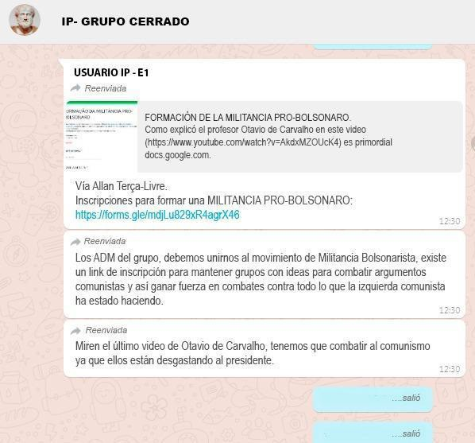
Note: Screenshot from WhatsApp, translation by the authors.

In general, the content that is most sent, shared, and commented on varies between photos, au- dio, and videos, among others. The easier it is to understand this content, the greater its rel- evance to the ideals of the communities (Netto & Peruyera, 2018; Alves, 2018), and the greater the possibility of starting a conversation around it. This type of fake news-oriented UGC is an example of the theory that points to users as generators and/or propagators of fake news, as Zhou and Zafarani (2020).
It is necessary to emphasize that it is not the shared content that is most important within the groups but the content that is generated thanks to the interactions between the users belonging to the groups (Terra, 2010).

CONCLUSIONS
It was possible to observe how this desire to be seen by other people is one of the main rea- sons why spreading fake news is so effective. This is mainly due to the social capital that fake news can provide to people, making the user an “influential” and trustworthy community member. This confirms part of the original hy- pothesis and fully addresses the problem pre- sented.
As a result of these issues, the results obtained in this study are inconsistent with one of the ideas initially proposed in the thesis that aimed at analyzing conflicting ideals. For this reason, it is believed that if such a perspective were to be applied, the understanding of people’s inter- actions with fake news and how social capital functions within groups would have a clearer and broader vision than the one obtained.

REFERENCES
Agostini, S., & Mechant, P. (2019). Towards a definition of virtual commu-
nity. Signo y Pensamiento, 38(74), 1-19. https://biblio.ugent.be/publica- tion/8632891.
Alves, L. (2018). Fake News: contra-ataque à pós-verdade. En 17 ART – 17°
Encontro Internacional de Arte e Tecnologia [Documento PDF] Media Lab. https://art.medialab.ufg.br/up/779/o/26-Lorena_Ferreira.pdf
Bakir, V. & McStay, A. (2018). Fake news and the economy of emotions: prob-
lems, causes, solutions. Digital Journalism, 6(2), 154-175. https://www. tandfonline.com/doi/full/10.1080/21670811.2017.1345645

Baudrillard, J. (1991). Simulacros e Simulação. Relógio d’Água.
Bondielli, A., & Marcelloni, F. (2019). A survey on fake news and rumour de- tection techniques. Information Sciences, 497(2019), 38-55. https:// doi.org/10.1016/j.ins.2019.05.035
Borges Junior, E. (2019). What is the post-truth? Elements for a critique of the
concept. Brazilian Journalism Research, 15(3). https://doi.org/10.25200/ BJR.v15n3.2019.1189
Deleuze, G. (2006). Diferença e Repetição [diferencia y repetición] (2a ed.). Graal.
DFNDR LAB.(2018) Relatório da Segurança Digital no Brasil Primeiro trimes- tre – 2018. [Documento PDF]. [S.I]. https://www.psafe.com/dfndr-lab/ wp-content/uploads/2018/05/dfndr-lab-Relatório-da-Segurança-Digi- tal-no-Brasil-Primeiro-trimestre-de-2018-1.pdf
Faucher, K. X. (2018). What is online social capital? En Social capital online: al- ienation and accumulation. (pp. 11-25). University of Westminster Press.
Genesini, S. (2018). A pós-verdade é uma notícia falsa. Revista USP, (116), 45- 58. https://doi.org/10.11606/issn.2316-9036.v0i116p45-58
Jenkins, H. (2008). Cultura da convergência. Aleph. Keyes, R. (2004). The Post-Truth Era. St. Martin’s Press. Kierkegaard, S. (1968). O conceito de angústia. Vozes.
Kozinets, R. (2019). Netnography: the essential guide to qualitative social media research. Sage Publications.
Lemos, A. (2002). Cibercultura, tecnologia e vida social na cultura contemporânea.
Sulina Universitária.
Maddox, A. M. (2020). Netnography to uncover cryptomarkets. En R. V. Kozinets & R. Gambetti (Eds.), Netnography Unlimited: Understanding Technocul- ture using Qualitative Social Media Research (pp. 24-43). Routledge.
Maffie, M. (2020). The Role of Digital Communities in Organizing Gig Workers.
Industrial Relations, 59(1), 123-149. https://doi.org/10.1111/irel.12251
McLuhan, M. (1964). Os meios de comunicação como extensões do homem . Ed- itora Cultrix.
Mishra, S. (2020). Social networks, social capital, social support and academ- ic success in higher education: A systematic review with a special fo-
cus on ‘underrepresented’ students. Educational Research Review, 29,
100307. https://doi.org/10.1016/j.edurev.2019.100307.

Netto, C., & Peruyera, M. (2018). Fake News como ferramenta de propagan- da política na internet. En Intercom – Congresso de Ciências da Comu-
nicação na Região Sul, 19. [Documento PDF] Paraná: Intercom. http:// portalintercom.org.br/anais/sul2018/resumos/R60-1637-1.pdf
Nietzsche, F. (1873). Sobre verdade e mentira no sentido extra-moral. Hedra. O’Connor, P. (2009). User-Generated content and travel: a case study on Tr-
ipadvisor. Information and Communication Technologies in Tourism 2008.
https://doi.org/10.1007/978-3-211-77280-5_5.
O’Leary, K. (2021). Netnography to explore gambling practices: situating and ad- vancing discourse and method. En R. V. Kozinets & R. Gambetti (Eds.), Netnography Unlimited: Understanding Technoculture using Qualitative So- cial Media Research (pp. 44-58). Routledge.
Peck, S. (1987). The Different Drum: Community Making and Peace. Touchstone.
Pennycook, G. & Rand, D. G. (2019). Lazy, not biased: Susceptibility to parti- san fake news is better explained by lack of reasoning than by moti-
vated reasoning. Cognition, 188, 39-50. https://doi.org/10.1016/j.cogni- tion.2018.06.011.
Primo, A. (2000). Interação mútua e reativa: uma proposta de estudo. Revista da Famecos, 81-92. http://hdl.handle.net/10183/238002.
Putnam, R. D. (2000). Bowling Alone: The Collapse and Revival of American Com- munity. Simon & Schuster
Quirós, E. (2017). Fake News versus jornalismo livre e independente. Revis-
ta UNO. https://www.revista-uno.com.br/numero-27/fake-news-ver- sus-jornalismo-livre-e-independente/
Recuero, R. (2009). Redes sociais na Internet. Sulina.
Recuero, R. (2012). O capital social em rede: Como as redes sociais na Inter- net estão gerando novas formas de capital social. Contemporanea: Re-
vista de Comunicação e Cultura, 10(3), 597-617. https://doi.org/10.9771/ contemporanea.v10i3.6295.
Rheingold, H. (1993). The Virtual Community: Homesteading on the Electronic Frontier. MIT Press.
Rodrigues, E. R. (2023). Capital social: uma análise do Brasil contemporâneo (2018-2022). (Tesis de pregrado, Universidade do Estado do Rio Grande do Sul). http://hdl.handle.net/10183/257773.
Salume, P. K., De Oliveira Guimarães, L., & Rantisi, N. M. (2019). Governance In Clusters: An Analysis From the Perspective of System Dynamics. Re-
vista de Empreendedorismo e Gestão de Pequenas Empresas. https://doi. org/10.14211/regepe.v8i2.1119.

Samuel, N. O. (2018). Bridging, Bonding, and Maintained Social Capital as Predic-
tors of Psychological Well-Being in a WhatsApp Group. https://hdl.handle. net/2142/10221.
Schechner, R. (2003). O que é performance?. Routledge.
Swanson, E. S., Kim, S. Y., Lee, S. H., Yang, J., & Lee, Y. (2020). The effect of lead- er competencies on knowledge sharing and job performance: Social
capital theory. Journal of hospitality and tourism management, 42, 88-96. https://doi.org/10.1016/j.jhtm.2019.11.004.
Tandoc, E. C., Lim, Z. J., & Ling, R. (2018). Defining “Fake News”: A typology
of scholarly definitions. Digital journalism, 6(2), 137-153. https://doi. org/10.1080/21670811.2017 .1360143.
Terra, C. F., & Corrêa, E. S. (2011). Usuário-mídia: a relação entre a comuni- cação organizacional e o conteúdo gerado pelo internauta nas mídias
sociais. (Tesis de doctorado, Universidade de São Paulo). https://doi. org/10.11606/t.27.2011.tde-02062011-151144
Thomas, C. G. (2021). Research methodology and scientific writing. Springer. Thompson, J. B. (1998). A mídia e a modernidade: uma teoria social da mídia.
Vozes.
Vosoughi, S., Roy, D., & Aral, S. (2018). The spread of true and false news
online. Science, 359(6380), 1146-1151. https://doi.org/10.1126/science. aap9559
Waisbord, S. (2018). Truth is what happens to news: on journalism, fake news, and post-truth. Journalism Studies, 19(13), 1866-1878. https://doi.org/1 0.1080/1461670x.2018.1492881.
Wardle, C. (2017). Fake news. It’s complicated. First Draft News. https://first- draftnews.org/fake-news-complicated/
Wellman, B., & Gulia, M. (2000). Net-Surfers Don’t Ride Alone: Virtual Commu-
nities as Communities. In Routledge eBooks (pp. 331–366) https://doi. org/10.4324/9780429498718-11
Westerlund, M. (2019). The Emergence of Deepfake Technology: A Review.
Technology Innovation Management Review, 9(11), 39-52. https://doi. org/10.22215/timreview/1282.
Zhou, X. & Zafarani, R. (2020). A survey of fake news: fundamental theories,
detection methods, and opportunities. ACM Computing Surveys, 53(5), 1-40. https://doi.org/10.1145/3395046.

